RPS Training Provider Application Form

To apply for accreditation by the Royal Pharmaceutical Society of Great Britain as a Training Provider please complete this form and submit it to our Accreditation Team together with the relevant accreditation fee at:
Royal Pharmaceutical Society,
66-68 East Smithfield,
London,
E1W 1AW
Please see payment form for payment methods
By submitting this Application Form you agree to the attached terms and conditions.

If your application is unsuccessful then we will refund the Fee to you less our administrative fee of £150 (plus VAT if applicable).

Applicant name:
Applicant details: | Contact name:  Address:  Phone:  Email:
Accreditation Period:
Fee:  Affiliated Partners will not be charged a fee for accreditation | £
Applicant signature: | ___________________________________  for and on behalf of the Applicant  Name of signatory:  Position:

Terms and Conditions
These terms and conditions and the Application Form to which they are attached (which together shall form the “Agreement”) set out the terms on which the Royal Pharmaceutical Society of Great Britain (“RPS” / “we”) may accredit the Applicant (“you”) as a Training Provider and the responsibilities you shall have if you are successfully accredited as a Training Provider.

By submitting your Application you agree to the terms of this Agreement.

- Definitions and interpretation

Words shall have the following meanings given to them in this Agreement:

“Accreditation Date” | - means the date on which we inform you in writing that your Application has been successful;
“Accreditation Period” | - means the period commencing on the Accreditation Date and continuing thereafter for the accreditation period specified in the Application Form;
“Accreditation Reviewer” | - means the relevant reviewer engaged by us to assess whether or not you meet the Principles;
“Application” | - means your application for accreditation as a Training Provider under this Agreement;
“Application Form” | - means your application form to which these terms and conditions are attached;
“Fee” | - means the fee specified in the Application Form;
“Principles” | - means the accreditation principles annexed to this Agreement, and which we may update from time to time. The Principles encompass the quality standards which you must meet in order to be and remain accredited as a Training Provider;
“Term” | - means the continuance of this Agreement from commencement until termination in accordance with clause 8;
“Trade Mark” | - means the trade marks set out in the Schedule;
“Trade Mark Licence” | - means the trade mark licence agreement which we will provide to you for your signature if your Application is successful, for your use of the Trade Mark;
“Training Provider” | - means a training provider that meets the Principles and has received accreditation as a recognised training provider by us.

In the event of a conflict between these terms and conditions and the Application Form, these terms and conditions shall prevail.

- Fee

You agree to pay to us the Fee upon submitting your Application to us.

For the avoidance of doubt, we shall not be required to consider your Application until we have received the Fee in full.

- Application process

Your Application shall be created and submitted by you in the utmost good faith and shall contain sufficient evidence to enable our Accreditation Reviewer to properly assess whether you meet the Principles and are suitable for accreditation as a Training Provider.

Our Accreditation Reviewer will consider:
  - if he/she requires further evidence from you to evaluate whether you meet the Principles and are suitable for RPS accreditation; if so, you shall endeavour to provide such further evidence to the Accreditation Reviewer as soon as practicable upon our or the Accreditation Reviewer’s request; and
  - whether you meet the Principles and are suitable for RPS accreditation
and report back to us with his/her assessment.

After considering the Accreditation Reviewer’s assessment, RPS will determine in its sole and absolute discretion as to whether or not to grant accreditation status to you and shall inform you of its decision.

If your Application is unsuccessful then we shall refund the Fee to you less our administrative fee of £150 (plus VAT if applicable).

- Accreditation as a Training Provider

If your Application is successful, we shall inform you of this and, on condition that you comply with your written assurances and the terms of this Agreement, you shall be accredited as a Training Provider for the Term.

From time to time we may request, and you will promptly provide to us on our request, written assurances to confirm that you are continuing to comply with the Principles and that you have acted and continue to act in the utmost good faith to us and in accordance with this Agreement. If we consider that either:
  - you are no longer compliant with the Principles or have not acted in accordance with this Agreement; or
  - you have within a reasonable time frame failed to provide sufficient information to enable us to evaluate your compliance with the Principles or with any undertaking in this Agreement
then we may withdraw and cancel your accreditation as a Training Provider by notice to you with immediate effect and without liability. In this event no refund of the Fee shall be given.

- Use of the Trade Mark

You are not permitted to use the Trade Mark until you have entered into the Trade Mark Licence; we shall provide you with a copy of this for your signature if and when we inform you that your Application has been successful.

You agree that you shall only use the Trade Mark during the Term and in accordance with the terms of the Trade Mark Licence.

- Confidentiality

Each party to this Agreement shall, and shall procure that its employees and representatives shall, keep confidential the terms of this Agreement and any other information disclosed to it and identified by the other party as being confidential.

The provisions of this clause 6 shall not apply to information which:
  - is or comes into the public domain through no fault of the recipient or its employees or representatives;
  - can be shown, to the discloser’s reasonable satisfaction, to have been already in the possession of the recipient, free from any obligation of confidentiality;
  - is lawfully received by the recipient from a third party free of any obligation of confidence at the time of its disclosure;
  - is independently developed by the recipient, without access to or benefit of such information; or
  - is required by law, by court or governmental or regulatory order to be disclosed provided that the relevant party, where it may do so lawfully and without breaching any of its duties under any regulations or to any third party, notifies the other party at the earliest opportunity before making any disclosure.
- Intellectual property

You warrant that:
  - all materials which you submit to us and our Accreditation Reviewer as part of your Application (“Application Materials”) shall fully comply with all applicable copyright and other laws; and
  - neither your submission of the Application Materials to us, nor our review of them, for the purposes set out in this Agreement shall infringe the intellectual property rights of any third party
and you shall indemnify us against all losses, damages, liability, costs (including legal fees) and expenses suffered or incurred by us arising out of or in connection with your breach of this clause 7.

- Term and termination

This Agreement shall begin on the date on which we receive your Application and shall, unless terminated earlier in accordance with its terms, continue until the expiry of the Accreditation Period or any Renewal Period (as defined below).

Before the end of the Accreditation Period or any Renewal Period we may, in our discretion, agree with you in writing to renew the Agreement for a further period (“Renewal Period”) in return for your payment of our applicable renewal fee. If such a renewal is agreed in writing, and you pay the applicable renewal fee, then the Agreement shall continue until the expiry of the Renewal Period.

Notwithstanding anything stated above in this clause 8,
  - this Agreement will immediately terminate where we either (i) withdraw and cancel your accreditation as a Training Provider in accordance with clause 4, or (ii) inform you that your Application has been unsuccessful in accordance with clause 3;
  - we may terminate this Agreement at any time and with immediate effect if you commit a material breach of this Agreement or if in our reasonable opinion the continuing accreditation of you as a Training Provider by us will likely damage RPS or bring RPS into disrepute.
No part of the Fee is refundable except to the extent expressly provided under clause 3.

The provisions of clauses 6 and 9 to 13 inclusive of this Agreement shall survive its termination.

- Liability limitation

Nothing in this Agreement shall limit or exclude any liability of a party which may not be limited or excluded by law, including without limitation liability for death or personal injury caused by its negligence or for fraud or fraudulent misrepresentation.

In no event shall we have any liability for removing your accreditation as a Training Provider.

- No assignment

This Agreement is personal to us and you and neither party may assign or transfer the benefit or burden of this Agreement without the prior written consent of the other party.

- Rights of third parties

A person who is not a party to this Agreement shall not have any rights under the Contracts (Rights of Third Parties) Act 1999 to enforce any of the provisions of this Agreement.

- Entire agreement

This Agreement and any documents entered into pursuant to it (including the Trade Mark Licence) constitute the entire agreement between us and supersedes all previous agreements, understandings and arrangements between us, whether in writing or oral, in respect of its subject matter.

- Choice of law and jurisdiction

This Agreement and any dispute or claim arising out of or in connection with it shall be governed by and construed in accordance with English law and the courts of England and Wales shall have exclusive jurisdiction to settle any dispute or claim arising out of this Agreement.

SCHEDULE

Trade Mark

1. ROYAL PHARMACEUTICAL SOCIETY ACCREDITED TRAINING PROVIDER 2017-2022

2.

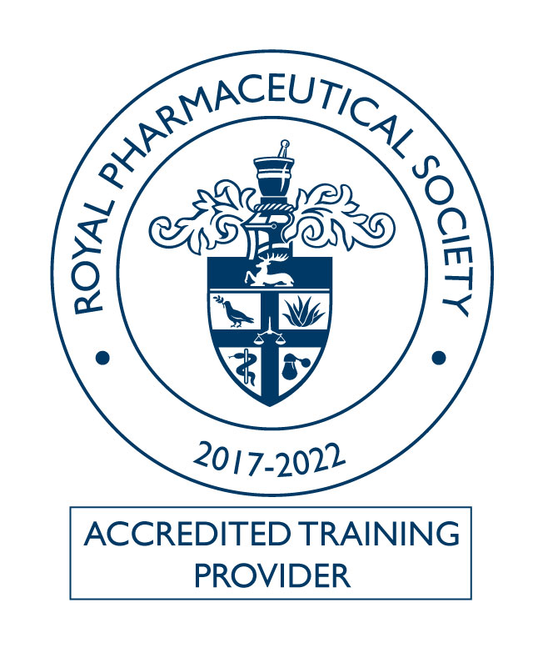

ANNEX

Principles
Please provide brief descriptions of the evidence you will provide to support your application in reference to the quality assurance points. Please add any further supporting documentation as an appendix.

Accreditation Principles | Examples of Evidence of how you might achieve the principle (Not Exhaustive) | Brief description of the evidence you will provide to support your application
Principle 1  Commitment to education and training | - Education strategy and delivery plans  - Involvement in training provision  - Training aligns to a business plan
Principle 2  Demonstration of a range of learning experiences for the learners | - Examples of training materials including face to face, distance learning materials, online training
Principle 3  Adequate infrastructure and resources to deliver the training | - Organisational chart  - List of facilities and resources  - List and cvs of staff delivering the training  - Recording data and tracking progress  - Security of students records and data  - Examples of teaching plans
Principle 4  Definition of performance criteria | - Learning outcomes  - Assessment or marking criteria  - Assessment or marking decisions  - Evaluation of assessments or marking  - Student feedback
Principle 5  Provision of evidence of monitoring and managing ‘pharmacists in difficulty’ | - Method of flagging ‘pharmacists in difficulty’ (or outcomes)  - A range of support systems and mechanisms  - Information on retakes or repeat attendance etc
Principle 6  Assurance of learning support for all learners | - Clear learning outcomes  - Easily accessible range of resources  - Sufficient numbers of tutors/supervisors to students  - Regular contact and feedback with tutors
Principle 7  Assurance of the management and quality assurance systems | - Sampling strategy/spot checks  - Tutor/Assessor support and monitoring  - Documentation of QA processes throughout and end of training  - Documented QA processes  - Complaints / Appeals process  - Policies such as Equal Opportunities and Special Learning Needs
Principle 8  Assurance of support, development and monitoring of tutors/teaching staff | - Commitment to developing staff  - Reviewing staff performances  - Monitoring and records of staff development  - Communication with staff  - Evidence of Mentoring  - Staff are RPS and Faculty members
Principle 9  Review and evaluation of procedures | - Trainer/assessor feedback  - Regular Student feedback of the course  - Action plans  - Feedback on updating course materials
Principle 10  Assurance of patient and public safety is being addressed in all areas of training and development | - Materials reflect current clinical, pharmacy practice, medicines management and national guidelines  - Aligns with RPS policies  - Evidence based
Principle 11  Provision of professional development | - Map training or learning to the Foundation Pharmacy Framework and Advanced Pharmacy Framework  - Maps to other frameworks  - Signposts to CPD

