

**Consultation closes Monday 11 September 2017**

Relevant to providers of pharmacy services in or to acute, mental health, private, community service, health and justice, hospice and ambulance settings

**Professional standards for pharmacy services: an updated draft for consultation July 2017**

**Contents**

1. Introduction 4

2. Scope of the professional standards for hospital services 5

3. Uses of the professional standards 6

4. The updated standards for pharmacy services 7

**When responding to this consultation please complete the following:**

|  |  |
| --- | --- |
| **Name:** |  |
| **Job title:** |  |
| **Organisation:** |  |
| **Professional background:** |  |
| **Are you an RPS member:** |  |

# 1. Introduction

* The Royal Pharmaceutical Society (RPS) is the body responsible for the leadership and support of the pharmacy profession within England, Scotland and Wales.
* One of the roles of a professional body is to develop professional standards that are supportive, enabling and professionally challenging. The importance of professional standards alongside regulatory standards in supporting patient safety has been repeatedly emphasised123
* There is a clear imperative for the providers of all pharmacy services to use professional standards to improve and develop services that are safe and put the needs of patients first. See figure 1 which describes where professional standards sit.
* 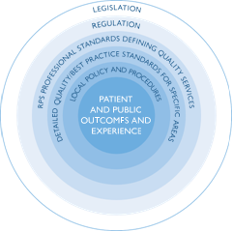In 2012 RPS professional standards for hospital pharmacy services were the first set of professional standards to be published by RPS. They are relevant to providers of pharmacy services in, or to, acute, mental health, private, community service, health and justice, hospice and ambulance settings.

#### FIGURE 1: WHERE THE RPS PROFESSIONAL STANDARDS ‘SIT’

***“The General Pharmaceutical Council believes that pharmacists and their teams should be aware of and use all relevant professional standards and guidance, both regulatory and professional, to deliver patient-centred care and good quality outcomes.” Duncan Rudkin, Chief Executive, General Pharmaceutical Council***

* The standards were refreshed in 2014 (primarily in light of the findings from the Francis Review of events at Mid Staffordshire Foundation Trust and the response to that review) and a full review was due in 2017.
* The review process has started and, following a [literature review](https://www.rpharms.com/making-a-difference/projects-and-campaigns/hospital-standards-update) and scrutiny by a multidisciplinary [steering group](https://www.rpharms.com/making-a-difference/projects-and-campaigns/hospital-standards-update) with lay representation, the standards have been updated. This document contains the draft updated standards and is being posted on the RPS website for a six week open consultation.
* The full process for updating the standards is outlined in the [RPS process development manual](https://www.rpharms.com/Portals/0/RPS%20document%20library/Open%20access/Manuals/How%20the%20RPS%20develops%20standards%20and%20guidance.pdf?ver=2017-05-31-143135-447).
* A detailed handbook supports implementation of the standards, providing links to legal frameworks and the core standards required by ‘systems’ regulators, as well as signposting to examples of good practice guidance. This [handbook](https://www.rpharms.com/resources/professional-standards/professional-standards-for-hospital-pharmacy/supporting-resources) will be updated alongside the professional standards (members only).

1 Francis R. Report of the Mid Staffordshire NHS Foundation Trust Public Inquiry. Feb 2013. <http://www.midstaffspublicinquiry.com/> (accessed 13.06.17)

2 Berwick D. A promise to learn - a commitment to act: Improving the Safety of Patients in England. 2013. [https://www.gov.uk/government/publications/berwick-review-into-patient-safety](https://www.gov.uk/government/publications/berwick-review-into-patient-safety%20) (accessed 13.06.17)

3 Trusted to Care. An independent Review of the Princess of Wales Hospital and Neath Port Talbot Hospital at Abertawe Bro Morgannwg University Health Board. May 2014. [http://gov.wales/topics/health/publications/health/reports/care/?lang=en](http://gov.wales/topics/health/publications/health/reports/care/?lang=en%20)   
(accessed 13.06.17)

# 2. Scope of the professional standards for hospital services

* The professional standards describe quality pharmacy services and provide a broad framework to support pharmacists and their teams to develop their professional practice, continually improve services, shape future services and roles, and deliver high quality patient care across all settings.
* The professional standards help to support a culture of openness, transparency and candour that puts patients first through encouraging professionalism. Ultimately, they will help patients experience a consistent quality of service within and across healthcare providers that will protect them from incidents of avoidable harm and help them to get the best outcomes from their medicines.
* The standards cover pharmacy services, whether provided internally or outsourced, and are broadly applicable across the full range of service providers. They are applicable in and across acute, mental health, private, community service, health and justice, hospice and ambulance settings. As new models of care develop and pharmacy services evolve the professional standards will continue to apply.

|  |
| --- |
| **QUESTION 1:** The title of the standards has been changed from Professional standards for hospital pharmacy services to Professional standards for pharmacy services to reflect that the standards are relevant to providers of pharmacy services in acute, mental health, private, community service, health and justice, hospice and ambulance settings. The change has also been made with a view to future proofing that standards as different models of care develop and pharmacy services are provided in integrated ways across care settings. |

|  |  |  |
| --- | --- | --- |
| **Do you agree with this change** | **Yes:** | **No:** |

|  |
| --- |
| **Comments:** |

# 3. Uses of the professional standards

* The standards give patients a clear picture of what they should expect in order to support their choices about, and use of, medicines when they experience care provided by (and transferred between) care providers
* Commissioners/purchasers of pharmacy services, regulators, insurers, Governments, and legislators have the standards as a framework for safety and quality that will help to inform and complement their own standards and outcomes

*“In England, the care quality commission already expects providers to reflect the key expectations of good practice guidance for their service, as they relate to the CQC essential standards of quality and safety. This good practice guidance would include the RPS professional standards.”* Brian Brown, National Pharmacy Manager, Care Quality Commission.

* Chief Pharmacists/Directors of Pharmacy have a consistent set of standards against which they can be held accountable and use as a framework to continually improve services, and innovate in their own organisations and with partners who deliver local health services
* The entire pharmacy team has a framework that allows them to recognise, develop and deliver the best possible outcomes for patients from pharmacy services.
* The standards provide a basis to develop more detailed standards for other areas for example [homecare](https://www.rpharms.com/resources/professional-standards/professional-standards-for-homecare-services) and [secure environments](https://www.rpharms.com/resources/professional-standards/optimising-medicines-in-secure-environments).
* The standards support benchmarking. See also [RPS definitions to support meaningful benchmarking](https://www.rpharms.com/Portals/0/RPS%20document%20library/Open%20access/Professional%20standards/Professional%20standards%20for%20Hospital%20pharmacy/Hospital%20pharmacy%20benchmarking%20metrics.pdf).

|  |
| --- |
| **QUESTION 2:** Have you used the professional standards yes/no? Please share how you have used the professional standards in practice? |
|  |

# 4. The updated standards for pharmacy services

* The project [steering group](https://www.rpharms.com/making-a-difference/projects-and-campaigns/hospital-standards-update) concluded, based on a literature view and the uses of the framework in practice that the framework required updating to reflect the changing nature of service delivery as well as a refocusing towards future roles and services. It was not the view of the group that the standards required a complete rewrite. The 2017 update to the framework is proportionate to that view.
* There are now eight standards for pharmacy services which have been grouped into three domains. Each standard is defined by dimensions and for each dimension statements describe what a quality pharmacy service should deliver.
* Taken together the eight standards reflect a quality pharmacy service and so all eight standards should be reviewed. Since the standards are relevant to the breadth of pharmacy service providers some of the underpinning dimensions and statements may be more relevant to some services than others.
* Similarly, there may be variation in the evidence used to assure the delivery of the standards, and the processes used to measure the achievement of the standards, in different organisations.
* The draft standards can be found on the following pages, when commenting on the standards please answer the questions after each domain. Please do not comment using tracked changes.

|  |
| --- |
| **QUESTION 3:** Given the scope of these standards, does the overall structure and content reflect your expectations of quality pharmacy services? If no please specify why not. |
|  |

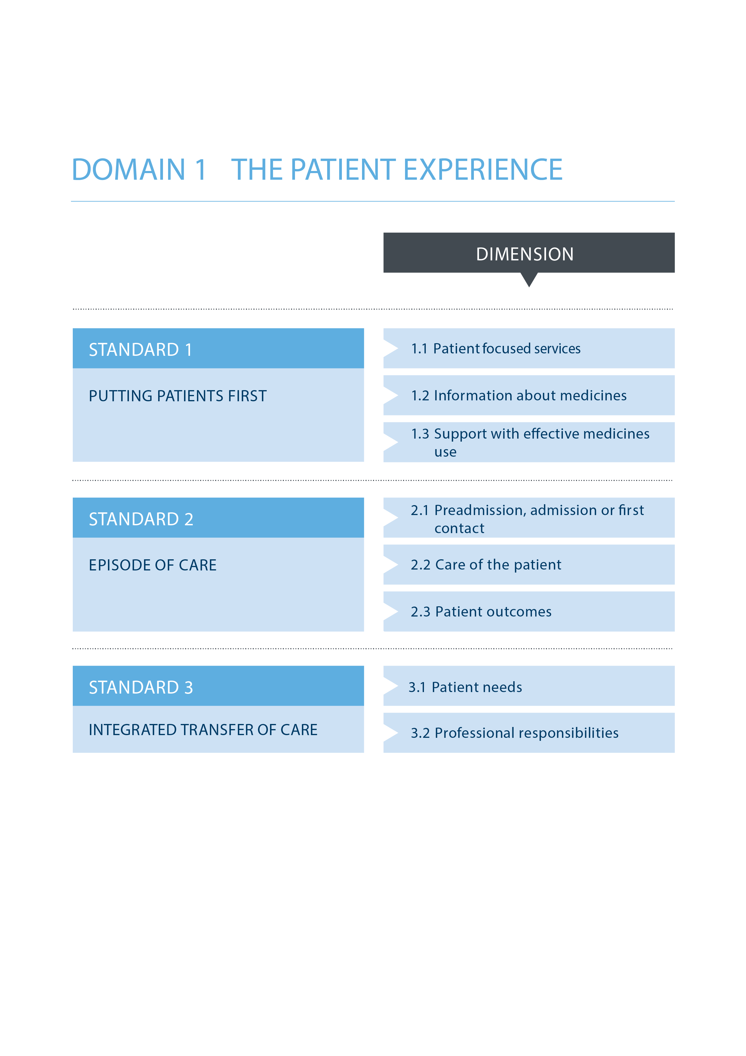

**STANDARD 1: PUTTING PATIENTS FIRST**

Pharmacy services enable patients to be fully involved in their own care and to make shared decisions about their treatment and their medicines.

* The standards refer to patient throughout however where the patient has a carer (see glossary) it is expected that the statements would apply equally to carers

|  |
| --- |
| **1.1 Patient focused services**  **The principle of “no decision about me, without me” underpins the design and delivery of pharmacy services.** |
| 1. Patients are treated with compassion, dignity and respect by all members of the pharmacy team. |
| 1. Pharmacy team members routinely introduce themselves and their role to patients. |
| 1. The views of patients are routinely sought to inform the development and delivery of pharmacy services, enabling patients to have direct input into the services that they receive. |
| 1. Pharmacy team members have the skills necessary to engage in meaningful conversations with patients about their care. |
| **1.2 Information about medicines**  **Patients have access to information and support in order to make shared decisions about the use of medicines or the implications of choosing not to take them*.** *\* When patients lack capacity appropriate procedures should be followed including those for Deprivation of Liberties, safeguarding and covert administration.* |
| 1. The pharmacy team provides the leadership, systems support and expertise to ensure that services can:  * Provide patients with information about medicines, their unwanted effects and how to manage and avoid them, in a form that they can access and understand. * Give patients the opportunity to have meaningful discussions about their medicines and treatments with an appropriate healthcare professional. |
| 1. The pharmacy team actively promote and facilitate the provision of clear, understandable information about medicines throughout the organisation and wider health system. |
| 1. Patients can get easy access to a pharmacy team member to discuss their medicines. |
| **1.3 Support with effective medicines use4**  **Systems are in place to identify patients who may need support, or to allow patients to request support with medicines choice and use.** |
| 1. Patients’ beliefs and expectations about, and experiences of, taking, their medicines are routinely explored to identify support required. Where difficulties are identified, further specialist input is provided. |
| 1. In partnership with the patient, medicines regimes are simplified as far as possible, doses optimised and medicines stopped when agreed it is in the best interests of the patient. Appropriate aids are made available to support patients. |
| 1. Liaison with other healthcare professions or agencies outside the organisation is undertaken where ongoing support with medicines is needed. |
| 1. When care is transferred to another setting, patients are referred or signposted to appropriate follow-up or support if needed with their medicines. |

*4 For England, see also* [*Medicines Optimisation: Helping patients to make the most of medicines*](https://www.rpharms.com/resources/ultimate-guides-and-hubs/medicines-optimisation-hub)

**STANDARD 2 EPISODE OF CARE**

Patients’ medicines requirements are regularly assessed and responded to in order to keep them safe and to optimise outcomes from medicines.

* The standards refer to patient throughout however where the patient has a carer (see glossary) it is expected that the statements would apply equally to carers

|  |
| --- |
| **2.1 On pre-admission, admission or at first contact (see glossary)**  **Patients’ medicines are reviewed to ensure an accurate medication history, for clinical appropriateness and to identify patients in need of further pharmacy support.** |
| 1. The pharmacy team provides the leadership, systems support and expertise that enables a multidisciplinary team to:  * Reconcile patients’ medicines and optimise treatment to identify and avoid potential medication-related problems before a planned admission; * Reconcile patients’ medicines within 24 hours of hospital admission to avoid unintentional changes to medication5 ; * Effectively document patients’ medication histories and identify medicines related admissions as part of the admission process; * Give patients access to the medicines that they need from the time that their next dose is needed minimising missed doses of medicines6 ; * Identify patients in need of pharmacy support and pharmaceutical care planning and document support necessary in the patient’s record; and * Identify potential medicines problems affecting discharge or transfer to another care setting so that they can be addressed to avoid risks to patient care and extending the patient’s episode of care. |
| **2.2 Care of the patient**  **Patients have their medicines reviewed by pharmacy team members who play an active role in the clinical management of patients. Patients can access the pharmacy expertise that they need to ensure that their medicines are clinically appropriate, and their outcomes from medicines are optimised.** |
| 1. Pharmacists clinically review treatment requirements to optimise outcomes from any medicines prescribed; frequency and level of review adjusted according to patient need. |
| 1. The pharmacy team work with colleagues to ensure that medicines are available and administered on time to avoid omissions and delay in treatment; pharmacy team members may also administer medicines to patients independently and/or support others during medicines administration rounds. |
| 1. Where pharmacy resources are insufficient to see all patients, patients have their medicines’ needs assessed and are targeted for clinical pharmacy support this support is documented in the patient’s record. |
| 1. Pharmacy team members are integrated into multidisciplinary teams across the organisation and provide patient facing clinical services to ensure safe and appropriate medicines use for all patients, whatever the setting. |
| 1. Pharmacist prescribers7 are integrated into relevant care pathways and prescribing regularly. |

5 RPS. [Hospital pharmacy benchmarking metrics – RPS definitions for use by hospital pharmacy teams. 2017](https://www.rpharms.com/Portals/0/RPS%20document%20library/Open%20access/Professional%20standards/Professional%20standards%20for%20Hospital%20pharmacy/Hospital%20pharmacy%20benchmarking%20metrics.pdf)  
6 RPS. [Hospital pharmacy benchmarking metrics – RPS definitions for use by hospital pharmacy teams. 2017](https://www.rpharms.com/Portals/0/RPS%20document%20library/Open%20access/Professional%20standards/Professional%20standards%20for%20Hospital%20pharmacy/Hospital%20pharmacy%20benchmarking%20metrics.pdf)  
7 Royal Pharmaceutical Society. A competency framework for prescribers. July 2016:   
 <https://www.rpharms.com/resources/frameworks/prescribers-competency-framework.>

|  |
| --- |
| 1. Pharmacy team members optimise treatment for patients, especially with identified high-risk medicines including antimicrobials, ensuring that medicines are used in accordance with local policies and/or reflect what is recognised as good clinical practice. |
| 1. Patients, medical and nursing teams have access to pharmacy expertise when needed. Specialist/advanced/consultant level pharmacists work in clinical specialties to maximise the availability of expert resource to other members of the multidisciplinary team for the benefit of patients receiving care in that area. |
| 1. The pharmacy team provides the support that enables patients to bring their own medicines into the care setting with them; staff encourage appropriate self-administration of medicines. |
| **2.3 Patients’ outcomes**  **Patients’ goals and outcomes from, and experiences of, treatment with medicines are documented, monitored and optimised.** |
| 1. As part of a multidisciplinary team, pharmacy team members monitor patients’ responses to their medicines and any unwanted effects of medicines. |
| 1. Appropriate action is taken where problems (potential and actual) are identified. |
| 1. The pharmacy team provides the leadership, systems support and expertise that enables healthcare professionals to:  * Help patients to avoid and/or minimise adverse events resulting from their medicines * Document, report* and manage any adverse events that do arise recognising duty of candour and transparency   * Adverse events should be reported to the Medicines and Healthcare products Regulatory Agency (MHRA) (via the Yellow Card Scheme and empower patients to report. |

## **STANDARD 3 INTEGRATED TRANSFER OF CARE**

Health and social care practitioners receive and share relevant information about the patient and their medicines when a patient transfers from one care setting to another.

* The standards refer to patient throughout however where the patient has a carer (see glossary) it is expected that the statements would apply equally to carers

|  |
| --- |
| **3.1 Patient needs**  **Patients are given information about their medicines and have their expressed needs for information met.** |
| 1. The pharmacy team provides the leadership, systems support and expertise to enable the organisation to support continuity of care and:  * Give patients information about their medicines in a form that they can understand before discharge or transfer to another service; * Advise patients who to contact if they need more information about their medicines, who will prescribe continuing treatment and how to access further supplies; * Identify and put in place measures to support patients at high risk of experiencing problems with their medicines on transfer to another care setting; and * Help patients find pharmacy support to improve health and wellbeing through public health services and activities when appropriate8. |
| **3.2 Professional responsibilities**  **Accurate and complete information about the patient’s medicines is transferred to the health or social care professional(s) taking over care of the patient at the time of transfer.8 Arrangements are in place to ensure a safe supply of medicines for the patient and ongoing support where necessary.** |
| 1. The pharmacy team provides the leadership, systems support and expertise to enable the organisation to:  * Transfer information about patients’ medicines to the professional(s) taking over care of the patient (e.g. general practitioner, community pharmacist, or care home or domiciliary care agency staff). * Ensure the accuracy, legibility and timeliness of information transfer9 * Ensure that patients have access to an ongoing supply of their medicines (based on local agreement and individual patient need) and share information so that their medicines can be reconciled by the health professionals taking over responsibility for care * Monitor, identify and minimise delays to patient discharge or transfer caused by delays in medicines to being supplied * Signpost or refer patients to sources of support for medicines use once they have been transferred to another setting |

8 RPS. Keeping patients safe when they transfer between care providers – getting the medicines right. June 2012 <https://www.rpharms.com/resources/reports/getting-the-medicines-right>   
9 RPS Professional Standards for Public Health Practice for Pharmacy <https://www.rpharms.com/resources/professional-standards/professional-standards-for-public-health>

## **QUESTION 4:** Given the level and scope of these professional standards, in the three standards for the *Patient Experience* domain, please consider the following:

|  |  |  |
| --- | --- | --- |
| **QUESTION 4a:** Overall, do the statements that support each standard reflect a quality service demonstrating delivery of that standard?  |  |  | | --- | --- | | **Yes:** | **No:** | |
| **If no, why not?** |

|  |
| --- |
| **QUESTION 4b:** Is there anything missing that you feel would demonstrate the delivery of the standard? Please specify |
|  |

|  |
| --- |
| **QUESTION 4c:** Are there any statements that you feel are unnecessary? Please specify |
|  |

|  |
| --- |
| **QUESTION 4d:** Are there any statements that you feel are unclear? Please specify |
|  |

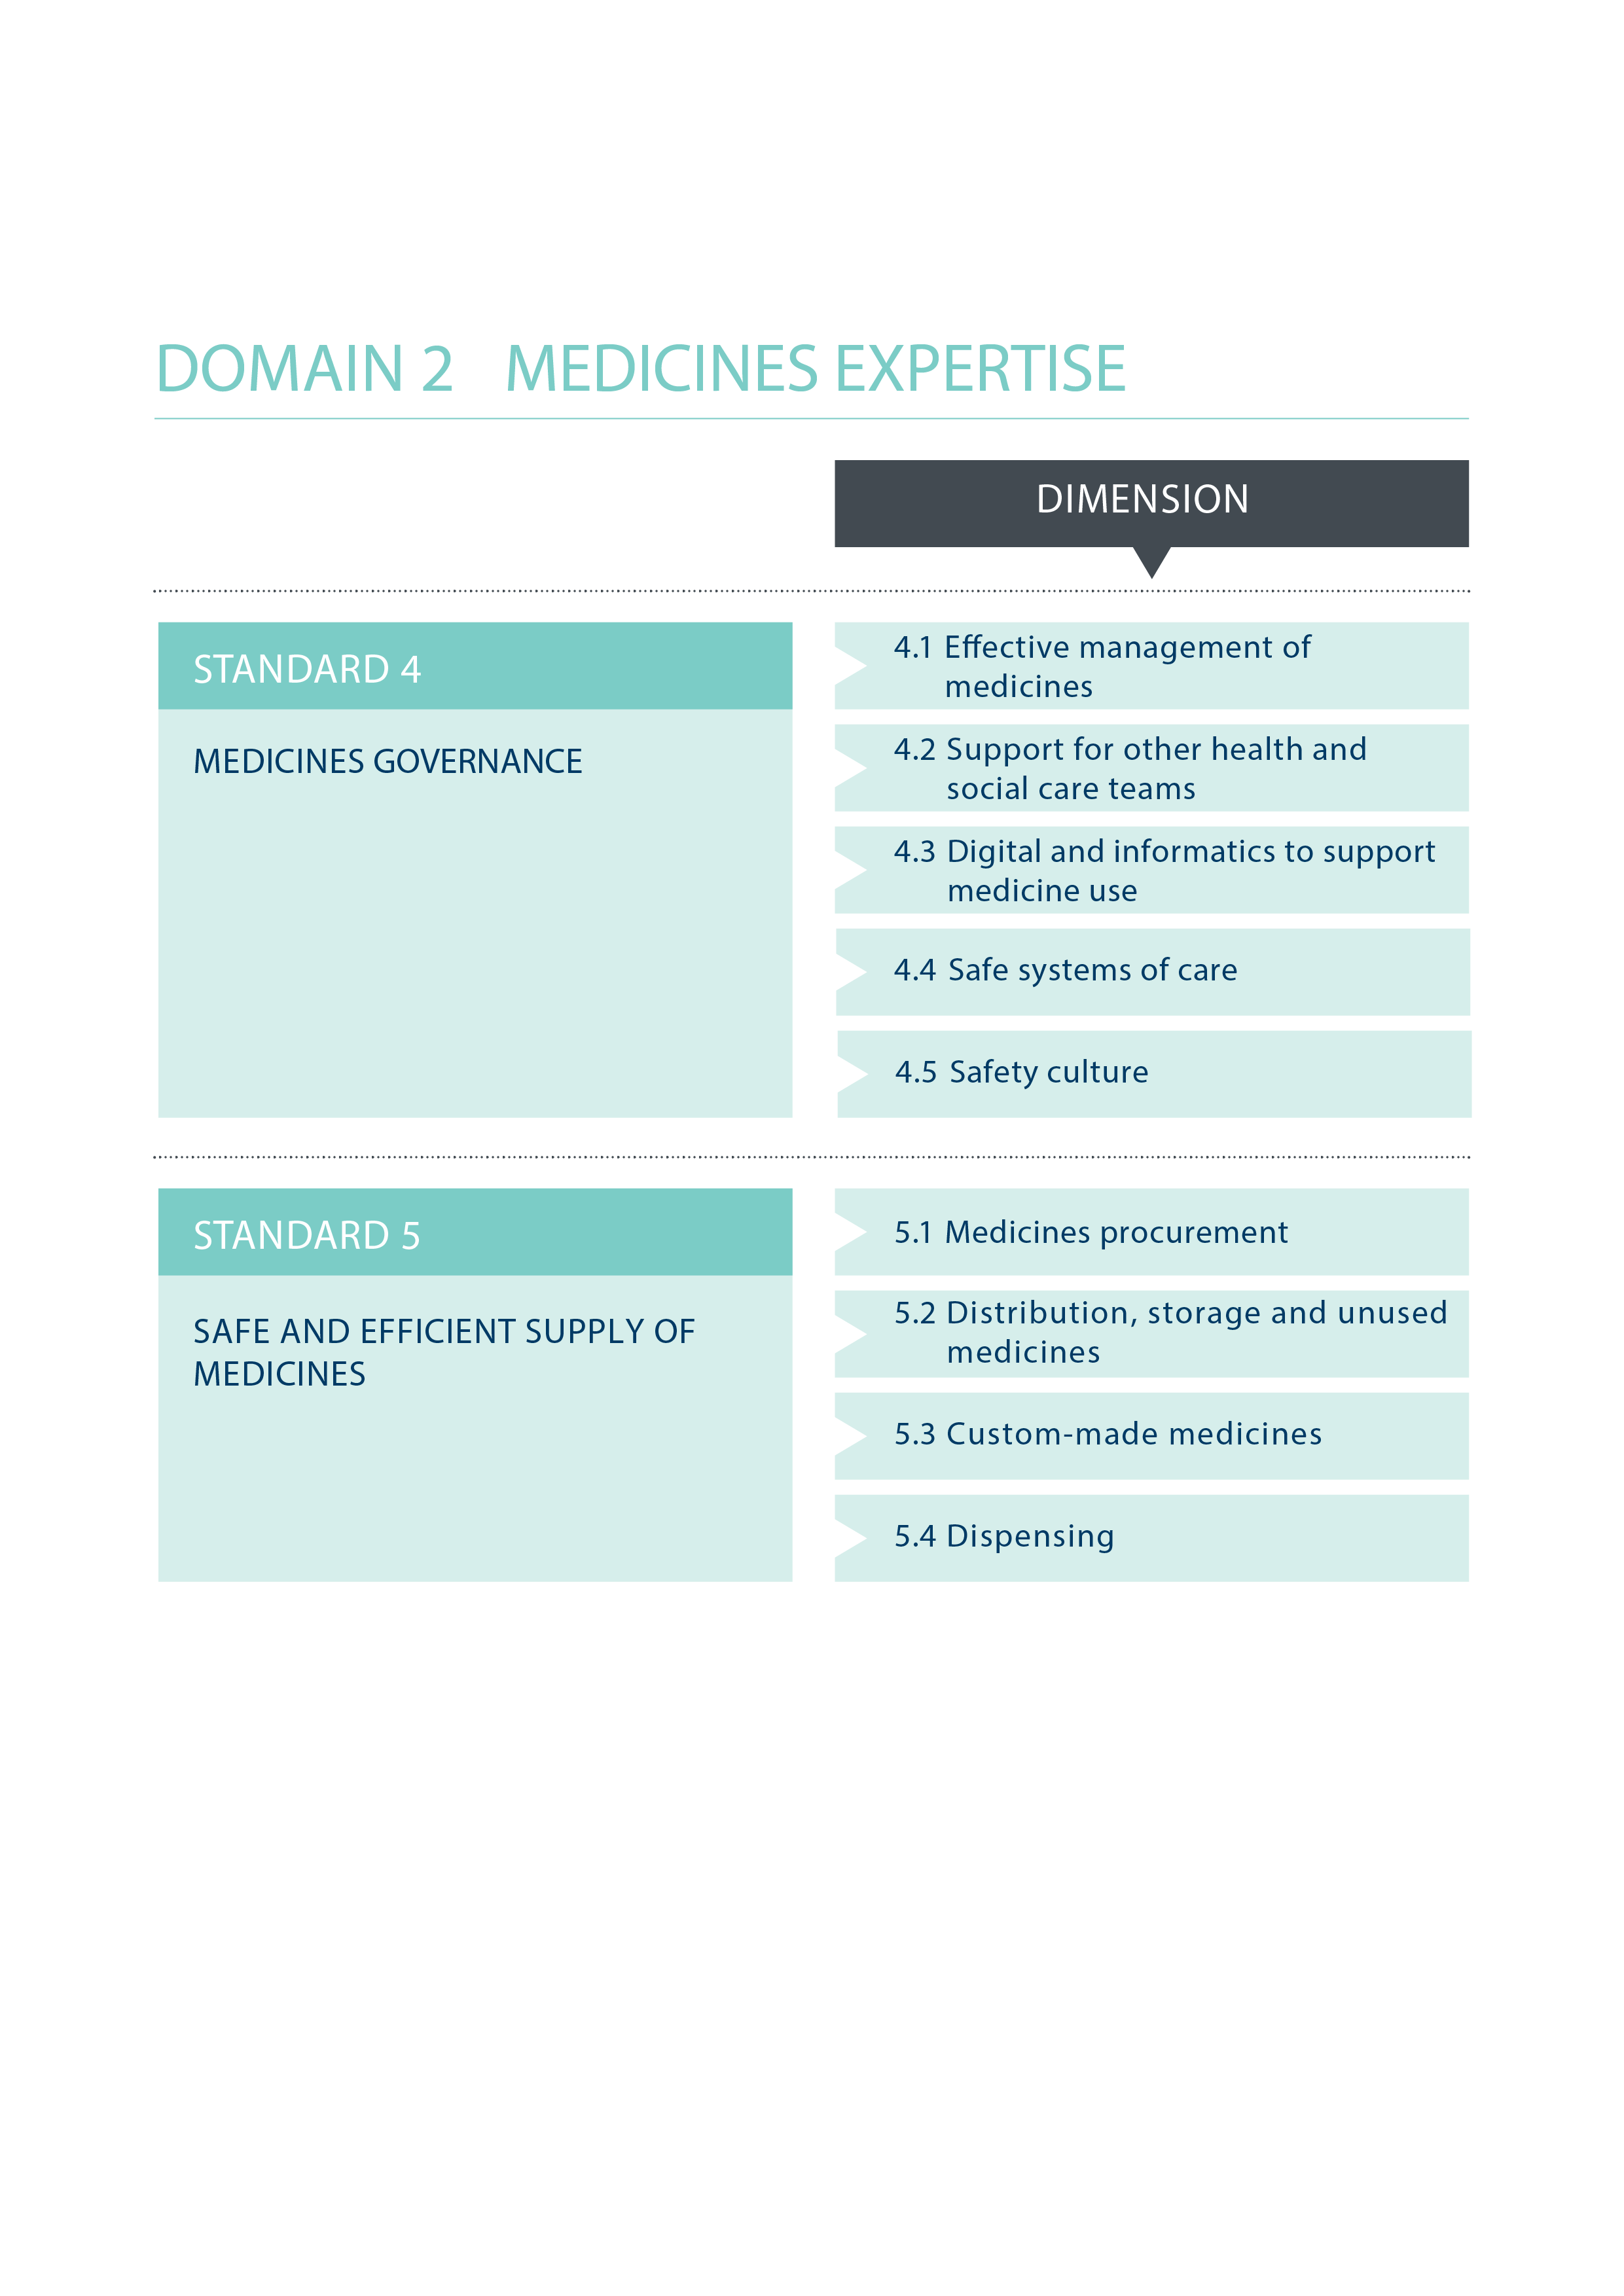

**STANDARD 4 MEDICINES GOVERNANCE**

Pharmacy expertise is available seven days a week to support the safe and effective use of medicines. The pharmacy team leads a multidisciplinary approach to safe medication practices.

* The standards refer to patient throughout however where the patient has a carer (see glossary) it is expected that the statements would apply equally to carers

|  |
| --- |
| **4.1 Effective management of medicines**  **Medicines policy aims to improve patients’ outcomes both on an individual and population basis maximising safety, effectiveness and the value obtained from medicines use.** |
| 1. A multidisciplinary group provides a focal point for the development of medicines policy, procedures and guidance within the organisation, and is appropriately resourced with pharmacist leadership and support. |
| 1. The pharmacy team leads the development and implementation of processes that ensure prescribing is safe, evidence-based, consistent with local, regional and/or national commissioning/purchasing arrangements, and linked to treatment guidelines, protocols and local patient pathways. |
| 1. Horizon scanning processes enable early discussions with clinicians, local partners and commissioners/ purchasers about the financial and service implications of the introduction of new medicines, new indications or new therapeutic practices. |
| 1. Controlled drugs are managed in line with the requirements of the Misuse of Drugs legislation and governance requirements. Regular updates and concerns about controlled drugs are reported to the Controlled Drugs Accountable Officer or an identifiable lead person. |
| 1. Governance arrangements are in place for the management of all medicines, including licensed medicines, off-label use of licensed medicines, unlicensed medicines and Investigational Medicinal Products (IMPs, ATIMPs, Clinical Trial medicines). |
| **4.2 Support for other health and social care staff**  **Health and social care staff prescribing, handling, administering and monitoring the effects of medicines have relevant, up-to-date, evidence-based information, policies and pharmaceutical expertise available to them at the point of care.** |
| 1. The pharmacy team supports induction, and ongoing training and education, in the best practice use of medicines for relevant clinical and support staff across the organisation. |
| 1. Pharmacy team members are accessible in (or to) clinical areas/teams to provide advice for other health and social care staff on the choice, use and handling of medicines. |
| 1. Access to a medicines information service is available to health and social care teams, working to national standards for medicine information. |
| 1. The pharmacy team works to ensure that prescribers are supported in their everyday activities with readily-accessible information and guidance. |
| **4.3 Digital technology and informatics to support medicines use**  **Pharmacy teams lead, with multidisciplinary engagement, the development of digital systems that support medicines use across the organisation and the wider health system. The pharmacy workforce has the necessary skills in clinical informatics to maximise the potential of digital systems and information.** |
| 1. Pharmacy services utilise digital systems (including automation) to underpin and transform the delivery of medicines optimisation/pharmaceutical care services |
| 1. Pharmacy informatics leaders ensure that digital systems comply with required standards and enable interoperability within and without organisations. |
| 1. Processes are in place to ensure that any system content relating to medicines is appropriately governed and backed up including looking for and managing unintended consequences of content changes or updates. |
| 1. Information generated through digital systems is used to optimise care with medicines whilst accommodating information governance and privacy issues. |
| 1. The pharmacy leadership and workforce have the necessary skills in clinical informatics to support optimisation of medicines. |
| 1. The pharmacy team is directly involved with the procurement, implementation, operation and development of electronic prescribing and medicines administration systems. |
| **4.4 Safe systems of care**  **The Chief Pharmacist (see glossary) leads a multidisciplinary approach across the organisation that ensures all aspects of medicines use within the organisation are safe.** |
| 1. The Chief Pharmacist ensures that pharmacy services operate a safety culture that aligns with the RPS professional standards for reporting, learning, sharing, taking actions and review of incidents10. |
| 1. The pharmacy team lead on developing, monitoring, reporting and improving metrics relating to safe use of medicines. Unintentional omitted and delayed doses are monitored, minimised and managed. |
| 1. The pharmacy team actively facilitates the timely implementation of relevant national therapeutic guidance and national patient safety guidance. |
| 1. Systems are in place to ensure appropriate and timely responses to national alerts, including national patient safety alerts, and Medicines and Healthcare products Regulatory Agency and supplier-led defective medicines alerts and recalls, within specified timescales. |
| **4.5 Safety culture**  **The Chief Pharmacist ensures that medication safety has a high profile, both within their organization and with partner organisations including those providing outsourced services.** |
| 1. The Chief Pharmacist has overall responsibility for medication safety and/or has direct access to Board support for the management of medicines safety in the organisation. |
| 1. The organisation has an identified individual/team with the experience, time and resources responsible for overview, reporting and learning from adverse events or near misses (for example Medication Safety Officer or equivalent) |
| 1. The Chief Pharmacist has representation on all high-level medicines safety and governance groups. |
| 1. An appropriate member of the pharmacy team must lead or be party to, Serious Incident (SI) investigations directly involving medicines or involving harm from the use of medicines. Systems and processes are in place to ensure other medication errors are identified, recorded, monitored, appropriately reported, investigated and practice changed to minimize recurrence. |
| 1. The pharmacy team actively works with, and where necessary intervene with prescribers, patients and other healthcare professionals to ensure medicines are safe and effective. |

10 Royal Pharmaceutical Society, Pharmacy Forum Northern Ireland and Association of Pharmacy Technicians UK. Professional Standards for the reporting, learning, sharing, taking action and review of incidents. November 2016. <https://www.rpharms.com/resources/professional-standards/professional-standards-for-error-reporting>

|  |
| --- |
| 1. Systems are in place to ensure patients who have experienced a medication error are informed, apologised to, and appraised of any action being taken to rectify the error. |
| 1. Learning from medication errors, near misses and systems failures related to medicines is shared with the multidisciplinary team and the whole organisation if appropriate, and acted upon to improve practice and safety. |
| 1. Shared learning is reviewed, reported at Board level on a regular basis, and shared within professional networks. |

**STANDARD 5 EFFICIENT SUPPLY OF MEDICINES**

Medicines supply is safe, efficient and timely seven days a week whether provided in house or outsourced.

* The standards refer to patient throughout however where the patient has a carer (see glossary) it is expected that the statements would apply equally to carers

|  |
| --- |
| **5.1 Medicines procurement**  **Medicines procurement is managed by pharmacy teams with relevant specialist expertise and knowledge in a transparent and professional way. Quality assured medicines are procured through robust and appropriate processes.** |
| 1. Procurement decisions are informed by clinical practice and formulary systems to ensure that medicines meet the needs of patients and the healthcare staff prescribing and administering them. |
| 1. Medicines procurement takes into account nationally or locally negotiated contracts and the quality and safety of the products. |
| 1. Contingency plans are in place to manage product recalls and shortages of medicines. |
| 1. All medicines (licensed and unlicensed) are assessed and assured to be of appropriate quality before supply to patients. |
| 1. Medicines procured are safely and securely received and stored in pharmacy, in accordance with relevant professional guidance and legislation. |
| **5.2 Distribution, storage and unused medicines**  **Medicines are safely and securely distributed from a pharmacy and stored in a secure and suitable environment prior to administration in line with professional guidance11.** |
| 1. Supply systems ensure that clinical areas have timely access to medicines needed routinely. Where necessary, medicines needed urgently outside core pharmacy service hours can be obtained. |
| 1. Policies, standard operating procedures (SOPs) and systems, informed and monitored by the pharmacy team, underpin the legal, secure and appropriate handling of medicines wherever they are located. |
| 1. Audit trails and governance processes are in place to underpin the supply, storage and disposal of medicines. |

11 Royal Pharmaceutical Society. Safe and Secure Handling of Medicines (currently being updated). [https://www.rpharms.com/making-a-difference/projects-and-campaigns/safe-and-secure-handling-of-medicines](https://www.rpharms.com/making-a-difference/projects-and-campaigns/safe-and-secure-handling-of-medicines%20)

|  |
| --- |
| **5.3 Custom-made medicines**  **Any medicines custom-made by, or for, the organisation are quality assured and appropriate for their intended use12.** |
| 1. Use of compounded, extemporaneously prepared, aseptically prepared, repacked and over-labelled medicines is consistent in line with regulatory requirements, the principles of risk reduction and using licensed medicines wherever possible. |
| 1. Aseptic preparation facilities (internal or outsourced) are subject to routine internal and external audit. |
| 1. Robust operator and patient safety systems are in place for the production of high-risk medicines, e.g. chemotherapy, radiopharmaceuticals, parenteral nutrition. |
| 1. Appropriate quality assurance and control systems underpin the selection, management and use of all custom- made medicines, whether produced internally or outsourced. |
| **5.4 Dispensing**  **Medicines that are clinically appropriate, are dispensed or prepared accurately, and available when needed** |
| 1. Before dispensing or preparation, prescriptions are reviewed for clinical appropriateness by a pharmacist. |
| 1. Systems are in place to prioritise dispensing in order to minimise the risks of omitted and delayed doses of critical medicines or of delayed discharge/transfer. |
| 1. Dispensing processes make appropriate use of technology, efficient ways of working and skill mix, e.g. automated systems, near patient dispensing, accuracy checking pharmacy technicians. |
| 1. Systems are in place to allow traceability of all dispensed medicines. |
| 1. Medicines are labelled for safety in line with legal requirements and professional guidance13. |
| 1. Systems are in place to identify and review the causes of dispensing errors, to minimise the future risk of these reoccurring. |

12 Beaney, A ed on behalf of the Royal Pharmaceutical Society and NHS Pharmaceutical Quality Assurance Committee. Quality assurance of aseptic preparation services: Standards. 5th edition. 2016. [www.rpharms.com/qaaps](http://www.rpharms.com/qaaps).

13 Royal Pharmaceutical Society. Medicines Ethics and Practice. [https://www.rpharms.com/resources/publications/medicines-ethics-and-practice-mep](https://www.rpharms.com/resources/publications/medicines-ethics-and-practice-mep%20)

## **QUESTION 5:** Given the level and scope of these standards, in the two standards for the *Medicines Expertise* domain, please consider the following:

|  |  |  |
| --- | --- | --- |
| **QUESTION 5a:** Overall, do the statements that support each standard reflect a quality service demonstrating delivery of that standard?  |  |  | | --- | --- | | **Yes:** | **No:** | |
| **If no, why not?** |

|  |
| --- |
| **QUESTION 5b:** Is there anything missing that you feel would demonstrate the delivery of the standard? Please specify |
|  |

|  |
| --- |
| **QUESTION 5c:** Are there any statements that you feel are unnecessary? Please specify |
|  |

|  |
| --- |
| **QUESTION 5d:** Are there any statements that you feel are unclear? Please specify |
|  |

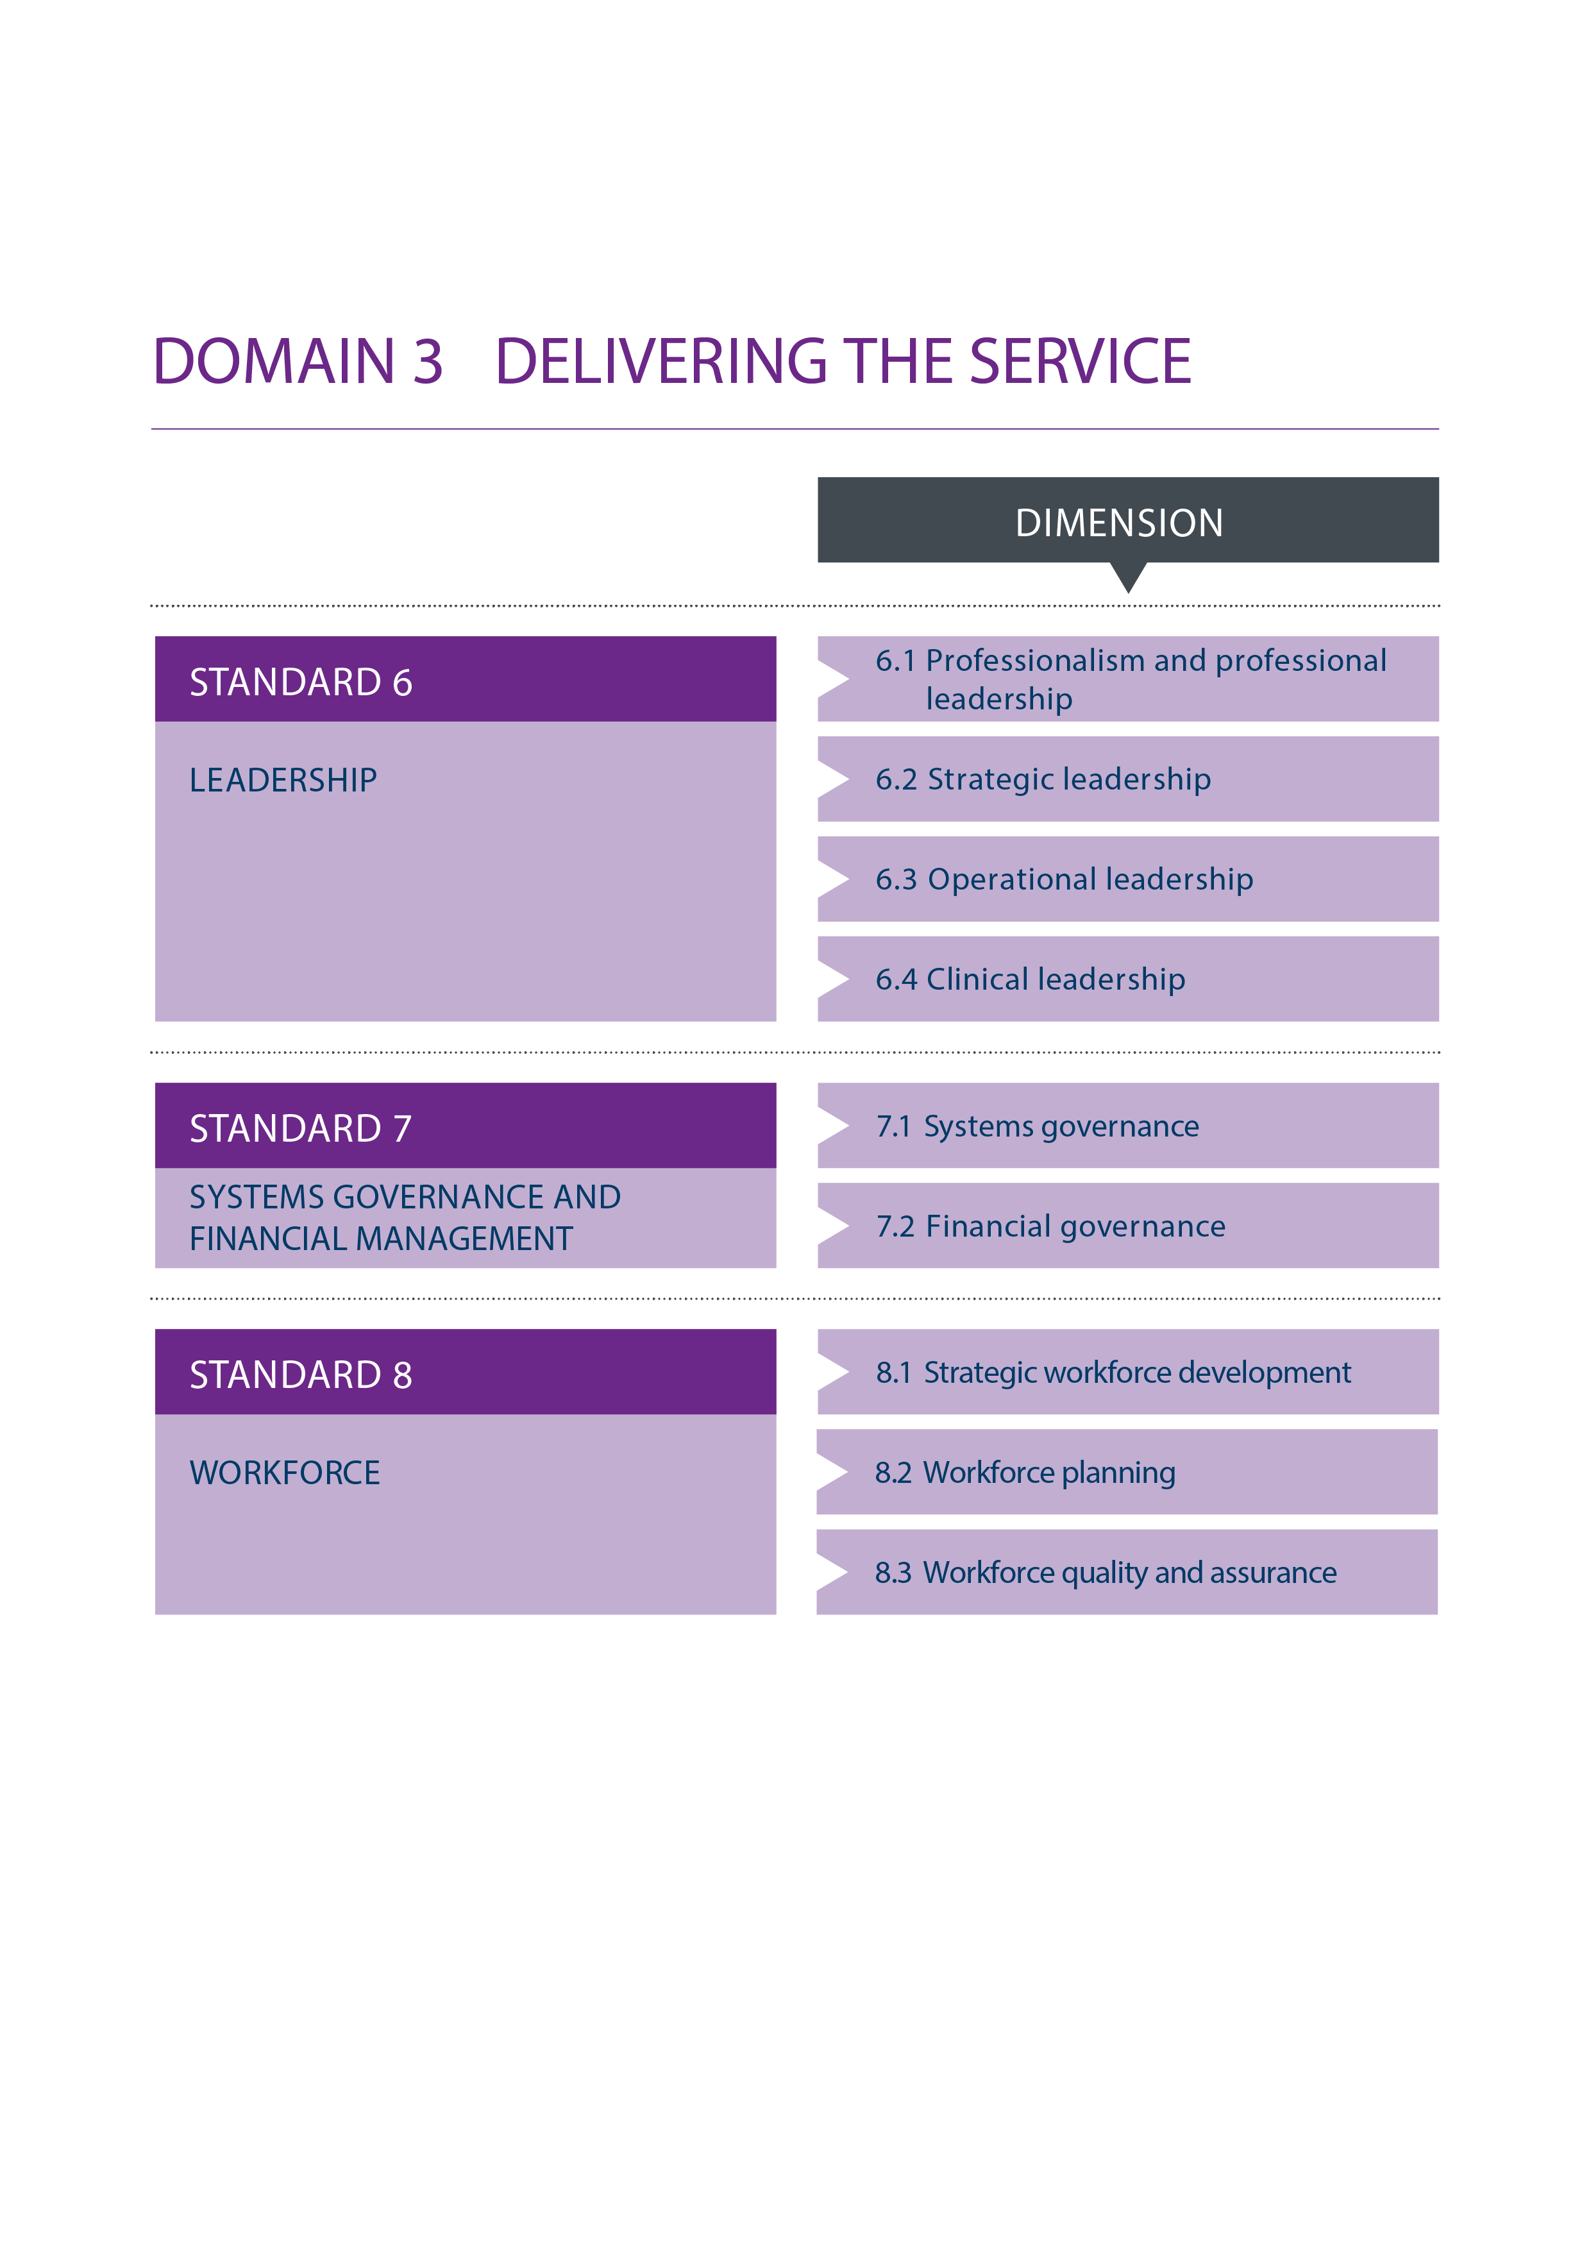

**STANDARD 6 LEADERSHIP**

Pharmacy has strong professional leadership, a clear strategic vision and the governance and controls assurance necessary to ensure patients are safe and get the best from their medicines14.

* The standards refer to patient throughout however where the patient has a carer (see glossary) it is expected that the statements would apply equally to carers

|  |
| --- |
| **6.1 Professionalism and professional leadership15**  **The pharmacy team recognises that they have a duty of care to patients and act in patients’ best interests.** |
| 1. The Chief Pharmacist leads by example through commitment, encouragement, compassion and a continued learning approach. |
| 1. The Chief Pharmacist promotes a just, open and transparent culture. |
| 1. Professional leadership at all levels is encouraged and developed. |
| 1. The pharmacy team behaves in a candid, open and transparent way acknowledging equality and diversity. |
| 1. Clinical supervision is an integral part of pharmacy team development. |
| 1. All members of the pharmacy team are encouraged and supported to raise any professional concerns they may have both from within the pharmacy service, and from other parts of the organisation. |
| 1. Professional concerns are investigated and, if substantiated, dealt with at an appropriate level in the organisation. |
| 1. All members of the pharmacy team manage conflicts of interest in line with organisational, national and professional guidance16. |
| **6.2 Strategic leadership**  **The Chief Pharmacist ensures that the organisation maintains a clear vision for pharmacy services and optimal use of medicines across the organisation and wider healthcare system.** |
| 1. The Chief Pharmacist is held accountable for the quality of medicines used and the standard of pharmacy services across the organisation. |
| 1. The Chief Pharmacist is, or reports to, a designated Executive Board member. |
| 1. The Chief Pharmacist provides assurance to the Board about the safe and effective use of medicines within the organisation through routine governance processes and risk management reporting. |
| 1. The organisation has a strategy and implementation plan for optimising patient outcomes from medicines that has Board approval and support and is regularly reviewed. |
| 1. The Chief Pharmacist collaborates on transformation of and innovation in service delivery to better meet patients’ needs, including the adoption of national initiatives and guidance, and encouraging the active involvement of patients. |
| 1. The Chief Pharmacist engages with the health community to develop a whole system approach to medicines and public health, including emergency preparedness, resilience and response. |

14 See also [RPS Leadership Competency Framework for Pharmacy Professionals](https://www.rpharms.com/resources/frameworks/prescribers-competency-framework).

15 See also [RPS The right culture for patient safety and professional empowerment](https://www.rpharms.com/resources/quick-reference-guides/the-right-culture)

16 [RPS A professional guide to support pharmacists identify and appropriately make declarations of interest. 2017](https://www.rpharms.com/resources/quick-reference-guides/declaring-interests)

|  |
| --- |
| **6.3 Operational leadership**  **Pharmacy services are patient focused safe, effective and efficiently delivered in line with national, regional and organisational priorities and the range and level of healthcare commissioned/purchased.** |
| 1. The type and level of resources required to deliver safe, effective and efficient pharmacy services and to support the safe and secure use of medicines are identified and available to the Chief Pharmacist. |
| 1. Agreed key performance and quality indicators are in place to enable internal and external assessment of the operational performance of pharmacy services. Operational performance is benchmarked against other relevant organisations using key information sources. |
| 1. All outsourced pharmacy services (including homecare and supply functions) are performance-managed through Service Level Agreements (SLA) and/or contract quality monitoring. Immediate action is taken if services fail to meet contracted standards. |
| 1. The pharmacy service structure has clear lines of professional and organisational responsibility established and is regularly reviewed. |
| 1. Feedback from patients and colleagues inform the development of services. |
| 1. Opportunities for collaboration and sharing best practice across healthcare organisations are identified and exploited |
| **6.4 Clinical leadership**  **The pharmacy team is recognised as leading on medicines, medicines use and innovations in medicines technology both within the organisation and across the health system.** |
| 1. The pharmacy team provides the leadership, advice, support and education to other clinicians and support staff about safe, cost-effective medicines usage. |
| 1. The pharmacy team ensures that their input is an integral part of the design of any services involving medicines. |
| 1. The pharmacy team supports the development of integrated care pathways that involve medicines as a treatment option. |
| 1. The pharmacy team leads, actively participates in and publishes research and quality improvement projects and seeks opportunities to work with academia and other research partners. |
| 1. The pharmacy team provides leadership and education on the introduction of complex therapies (genomics, personalised and precision medicine etc) in collaboration with the multidisciplinary team. The potential implications for service delivery are understood and new or innovative services are planned and designed around the needs of patients. |

**STANDARD 7 SYSTEMS GOVERNANCE AND FINANCIAL MANAGEMENT**

Safe systems of work are established and pharmacy services have sound financial management.

* The standards refer to patient throughout however where the patient has a carer (see glossary) it is expected that the statements would apply equally to carers

|  |
| --- |
| **7.1 Systems governance**  **Systems of work are established that are safe, productive, support continuous quality improvement, are regularly audited and comply with relevant regulations.** |
| 1. The continuous quality improvement and development of systems is informed by a programme of audit and/or other improvement techniques/methodologies. |
| 1. Care contributions are documented and audited to demonstrate the impact of the service on patient outcomes. |
| 1. Pharmacy services have effective feedback systems for patients and staff to use that are aligned to organisational systems encouraging patient safety, continuous learning and service improvements. |
| 1. All pharmacy team members are trained in information governance to safeguard patient-identifiable information about care/medicines supplied. |
| 1. Governance systems are in place for working with the pharmaceutical industry. |
| 1. Working environments are planned and maintained in line with Health and Safety requirements, regulatory and professional best practice standards. |
| 1. Equipment and systems are maintained and operated only by appropriately trained members of the team or external contractors. |
| 1. Standard operating procedures (SOPs) are in place for the delivery of all pharmacy services across the organisation. |
| 1. Business continuity plans are developed and maintained for all services, and risk registers with appropriate escalation mechanisms are maintained. |
| **7.2 Financial governance**  **Robust business planning, financial planning, cost improvement plans and reporting are undertaken.** |
| 1. A business plan for pharmacy services, incorporating finance, service and workforce plans, linked to the organisation’s corporate plan is devised, implemented and monitored. |
| 1. National initiatives and guidance relating to medicines and pharmacy are incorporated into service planning activities. |
| 1. Medicines use and expenditure reports are interpreted and used to support budget management and monitoring of clinical practice. |
| 1. The pharmacy team regularly engages with commissioners and primary care to review prescribing in order to deliver value across the health system. |

**STANDARD 8 WORKFORCE**

The pharmacy team has the right skill mix, capability and capacity to provide safe, quality services to patients.

* The standards refer to patient throughout however where the patient has a carer (see glossary) it is expected that the statements would apply equally to carers

|  |
| --- |
| **8.1 Strategic workforce development**  **The pharmacy team is developed to meet the needs of patients across the health and social care system** |
| 1. Workforce development is in the pharmacy strategic plan and linked to the organisational strategic workforce plan. |
| 1. Workforce development takes a needs-based approach focusing on future service needs and new models of care, and engaging with local service planners, education commissioners and members of the multi-disciplinary team. |
| 1. Skill mix is reviewed across the pharmacy and wider clinical team taking into account changing patient demographics, advances in technology and the effective use of available and future staff resources |
| 1. Roles are designed that support new models of integrated care that enable collaboration across the wider multi-disciplinary team in all sectors |
| 1. The outcomes of workforce development plans deliver cost-effective use of staff practicing at their highest skill level. |
| 1. The development of advanced pharmacy roles achieves the right balance between generalists and specialists necessary to meet the needs of patients. |
| **8.2 Workforce planning**  **The pharmacy workforce is planned to ensure sustainability** |
| 1. In collaboration with local commissioners the training pipeline secures sustainable numbers within all parts of the pharmacy team. |
| 1. Imbalances in supply and demand for pharmacy staff are understood and corrective measures put in place considering quality, accessibility and acceptability for patients. |
| 1. Succession planning arrangements are in place and are linked to workforce training and personal development plans. |
| **8.3 Workforce quality and assurance**  **Operational policies, procedures and plans are in place to ensure that the pharmacy workforce is managed and appropriately resourced in order to support service quality, productivity and safety.** |
| 1. All members of the pharmacy team are clear about their role and responsibilities and aware of their level of performance and competency as part of a robust annual appraisal and performance and talent review process. Personal development plans highlight appropriate professional, managerial and leadership frameworks, tools and assessments |
| 1. Safe staffing levels are reviewed and set to ensure the delivery of daily services |
| 1. A culture of lifelong learning is demonstrated and all members of the pharmacy team acknowledge their role as learners, educators and trainers. Tutors, mentors and trainers have been trained appropriately and meet the relevant RPS and Association of Pharmacy Technicians UK (APTUK) standards and guidance. |
| 1. Continued learning and professional/personal development opportunities are provided for all members of the pharmacy team |
| 1. All early years pharmacists have access to Foundation Training and support via the RPS or an RPS accredited Foundation Programme17. All early years pharmacy technicians have access to foundation training and support via the APTUK Foundation Pharmacy Framework. |
| 1. All pharmacists registered for greater than two years are RPS faculty members or working towards this through the Faculty Programme |

17 <https://www.rpharms.com/professional-development/foundation-programme>

## **QUESTION 6:** Given the level and scope of these standards, in the three standards for the *Delivering the Service* domain, please consider the following:

|  |  |  |
| --- | --- | --- |
| **QUESTION 6a:** Overall, do the statements that support each standard reflect a quality service demonstrating delivery of that standard?  |  |  | | --- | --- | | **Yes:** | **No:** | |
| **If no, why not?** |

|  |
| --- |
| **QUESTION 6b:** Is there anything missing that you feel would demonstrate the delivery of the standard? Please specify |
|  |

|  |
| --- |
| **QUESTION 6c:** Are there any statements that you feel are unnecessary? Please specify |
|  |

|  |
| --- |
| **QUESTION 6d:** Are there any statements that you feel are unclear? Please specify |
|  |

**Glossary**

|  |  |
| --- | --- |
| **APTUK** | The Association of Pharmacy Technicians UK is the Professional Leadership Body for registered pharmacy technicians working in the UK. |
| **CARER** | A person who provides support and assistance, formal or informal, with various activities to patients (see glossary definition). This may be emotional or financial support, as well as hands-on help with different tasks. Carer in this document is an umbrella term also used to cover parents, patient advocates or representatives. |
| **CHIEF PHARMACIST** | The senior pharmacist with overall responsibility for pharmacy services or medicines optimisation/pharmaceutical care in the organisation. Organisations across GB have a range of different names for this role including Director of Pharmacy. For the purpose of this document we refer to Chief Pharmacist throughout. |
| **CLINICAL SUPERVISION** | A formal process of professional support and learning that enables individual practitioners to develop knowledge and competence, assume responsibility for their own practice, and enhance patient protection and safety of care in a wide range of situations. |
| **FIRST CONTACT** | The first point at which a patient accesses pharmacy services this could be (but is not limited to) ambulatory care, community clinics, intermediate care, health and justice settings, hospices. |
| **INFORMATICS** | A general term used to refer to biomedical informatics and its many areas of application and practice (e.g., bioinformatics, clinical informatics, public health informatics). |
| **PATIENT** | Used as an umbrella term to cover the full range of people using pharmacy services across sectors this includes children and young adults, service users and clients. |
| **PHARMACY TEAM** | Pharmacy team encompasses pharmacists, pharmacy technicians and pharmacy assistants. |

FURTHER QUESTIONS

|  |
| --- |
| **QUESTION 7a:** Are there any statements where you feel that a case study would be helpful to illustrate how to apply the standard in practice? Please specify. |
|  |

|  |
| --- |
| **QUESTION 7b**: Do you have any case studies that you would like to share? Please give details. |
|  |

|  |
| --- |
| **QUESTION 8:** What might be the financial and/or organisational barriers to using these standards in practice? |
|  |

|  |
| --- |
| **QUESTION 9**: Are there any supporting references or resources that you feel should be included in the Handbook to support implementation of the standards in practice? |
|  |

|  |
| --- |
| **QUESTION 10**: Are there any other comments that you would like to make about the standards? |
|  |

##### Thank you for taking the time to respond to this consultation. Please return this document to [support@rpharms.com](mailto:support@rpharms.com)

(Consultation closes 11 September 2017)





Copyright © The Royal Pharmaceutical Society 2017. All rights reserved. This publication may not be redistributed or reproduced in whole or in part without the permission of the copyright holder.

**About Us**

The Royal Pharmaceutical Society (RPS) is the professional body for pharmacists and pharmacy in Great Britain. We represent all sectors and specialisms of pharmacy in Great Britain and we lead and support the development of the pharmacy profession to deliver excellence of care and service to patients and the public. This includes the advancement of science, practice, education and knowledge in pharmacy and the provision of professional standards and guidance to promote and deliver excellence. In addition we promote the profession's policies and views to a range of external stakeholders in a number of different forums.