**System-wide Delivery of Medicines Homecare**

**Output Based Specification**

**Contents**

Executive Summary 3

Background and Overview 4

Introduction 4

Hackett Report 5

Homecare Policy 5

Document Objectives 5

History 6

Strategic Context 7

Key Benefits 7

Strategic Papers 8

VAT 8

Patient Journey Overview 9

Homecare Medicines – A vision for the future 10

Systems Workstream 10

Workshop 10

Stakeholders 11

What is an OBS? 11

Systems Development 11

Electronic transfer of Prescriptions Service 11

Business Requirements Overview 13

Key Functional Areas 13

Key Processes 14

Prioritised Requirements List 15

Fundamentals 15

Prioritisation 15

Searchable List 15

Patient Requirements 16

Clinical Requirements 17

Pharmacy Requirements 19

Commercial Requirements 20

Appendix 1 – RCP Health and Social Care Standards for Electronic Records 24

Appendix 2 – Ideal Patient Journey 26

Appendix 3 – References 27

Appendix 4 – Glossary of Terms 28

# Executive Summary

**Homecare Success Story**

The Hackett report demonstrates the success of the Homecare market, but that risks have developed in the system, especially with the growth rates out stripping investment.

Some Trust/Organisations are better placed than others to manage these risks, and there are also system inefficiencies as the processes are largely manual and not cohesive. Some Trust/Organisations are struggling to keep up with the demand often leading to higher costs and lack of visibility needed to manage the Homecare Medicines Services .

A more efficient, integrated set of procedures and processes are required managed by an interoperable IT solution with the Patient at the centre.

The following shows an example of the medicines spend growth rates as submitted by the Commercial Medicines Unit (CMU):

**Homecare Key Benefits**

This document (OBS) shows that Investment in an interoperable IT Solution is needed to:

* Improve Treatment Outcomes
* Increase Patient Independence & Experience
* Make Time and Economic Savings for all (Patients, NHS and Homecare Providers)
* Manage Future Growth
* Improve Governance and Accountability.

The associated Outline Business Case that accompanies this document will give an estimate of the order of magnitude of the Cost/Benefits and Timescales etc.

**Homecare Key Requirements**

* Patient centric - Patient choice, Patient must feel in control
* Interoperable IT solution - linking Clinical, Pharmacy, Homecare Providers and Financial systems
* Any solution must deliver better care and cost savings for the NHS & Homecare Providers

**Homecare Roadmap**

Homecare recommended plan (as defined in the Outline Business case) has the following milestones and deliverables:



Figure 1 - Homecare Roadmap

# Background and Overview

## Introduction

The Government puts patients at the heart of the NHS and everything that it does and is seeking to empower and liberate clinicians to innovate with freedom to improve health services.

It also recognises that Homecare medicines can transform peoples’ lives and add significantly to life expectancy.

Homecare medicine brings the redesign of NHS services and recognition of the role that medicines play, together, around a single natural focus.

The use of medicines plays a vital role in the delivery of high quality care and accounts for over 12% of NHS expenditure. In 2009 -10, the NHS drugs bill was approximately £11.9 billion, equivalent to around 12% of the entire NHS budget and was the biggest single item of spend after staff. Of this around £7.9 billion was spent in primary care and £4 billion in secondary care.

The Homecare drug cost is now estimated as being over 25% of the secondary care - £1 billion, and growing at 4.6% per year. Hence in 2011, the Chief Pharmaceutical Officer commissioned Mark Hackett (formerly Chief Executive at University Hospital, Southampton NHS Foundation Trust) to review the homecare market because:

* The rapid expansion of homecare medicine with a lack of national visibility and concern that the DH was unable to advise ministers on policy options.
* The related inability to secure a national understanding of homecare medicine with concerns about how the NHS managed this business and the thought it was giving to strategic intent.
* The recognition that ‘getting homecare medicine right’ was important to taxpayers and patients, not least because of the contribution that homecare medicine supply will play in delivering a strategic shift of caring for patients in their own homes.

## Hackett Report

Mark Hackett, formerly chief executive University Hospital Southampton NHS Foundation Trust, led the work. The report made a list of recommendations to improve the financial and clinical governance arrangements for patients receiving medicines via the homecare route[1].

In April 2012 Mark Hackett established a Homecare Medicines Strategy Board to oversee a national implementation of the recommendations[2]. The steering board work streams (and their key deliverables) are as follows:

* Patient engagement:
  1. A patient charter
  2. A model for patient engagement
  3. A guide for patients on patient choice
* Acute trust engagement, governance and clinical relationships:
  1. A guide to good governance for acute trusts
* Systems: Homecare modules and functionality:
  1. Short term recommendation on system solutions
  2. Output Based Specification for a new homecare medicine system solution (i.e. this document)
* Toolkit and standards[3]:
  1. A framework of standards for homecare medicines
  2. A toolkit for the NHS to support the management of homecare medicines
  3. Outline expertise and knowledge for the operation of homecare medicines
* Development of procurement model:
  1. A set of procurement standards
  2. Improvements to the existing procurement process.

## Homecare Policy

Homecare is defined as a service that regularly delivers medicine supplies and associated care that do not require hospital admission, directly to a patient’s choice of location – NB this is NOT the same as Hospital at Home. Homecare services are split between those which are set up by the Pharmaceutical Industry for individual products and those services which are contracted to an NHS specification. There are different levels of Homecare service from simple dispensing and delivery (low tech) to more complex aseptic preparation and the inclusion of nurse administration (high tech).

The use of a homecare service should not reduce or alter the NHS duty of care to patients. The Trust/Organisation and the patient’s clinical team will retain responsibility for the clinical aspects of a patient’s treatment. Areas of responsibility need to be clearly defined for all parties with SLAs (or equivalent) to guarantee a quality service.

Please note, the model policy for Homecare can be found in the Expertise, Toolkit and Standards (see reference 2).

## Document Objectives

This Output Based Specification (OBS) defines the scope of Homecare best practises recommended by the Hackett report and the steering group key deliverables (such as the Toolkit of standards). These best practises are captured as a list of the Homecare Requirements and associated priorities.

Once agreed this OBS can then be used to secure funding and agree system standards between all NHS and Commercial stakeholders, to build an integrated framework linked to NHS and Commercial IT applications to provide a seamless Homecare patient experience.

The full terms of reference can be found in the Hackett report.

The associated Outline Business Case that accompanies this document defines the Cost/Benefits and Outlines Timescales, future Deliverables; hence this document does not outline a plan or describe “what’s next”.

## History

Since 1995 (when the DH issued EL95/5) the scope of homecare medicine has grown far beyond the originally identified therapies. It now includes both high and low technologies — products and services — and is now referred to as homecare medicines delivery and services:

* High-tech Homecare Medicine and Services includes:
  + Injectable therapy, e.g. intravenous route
  + Oral therapies that require significant support such as blood level monitoring or special storage requirements.
* Low-tech Homecare Medicine and Services tend to involve oral medication and requiring limited technical support such as standard concordance monitoring from the homecare provider.

Homecare medicines delivery and services are predominately provided by the commercial sector. There is evidence of services such as nursing within Home Parenteral Nutrition or dialysis being provided by both the NHS and the commercial sector; i.e. homecare provider or manufacturer.

To initiate homecare medicine supply from a homecare medicines delivery service provider:

* An NHS Trust/Organisation may provide on order
* An NHS Trust/Organisation prescriber may provide an FP10 HP prescription
* And on rare occasions commissioning organisation may order and maintain supply

Operating as a registered pharmacy, the homecare service provider will then dispense the medicine against the order (with it effectively being a private prescription) for supply to the named patients in their home.

CMU submitted the following Pharmex analysis:

|  |  |  |  |  |  |  |
| --- | --- | --- | --- | --- | --- | --- |
| Purchase Year | Homecare Spend (£m) | Non-homecare Spend (£m) | Homecare/ Non‑homecare (%) | **Homecare rate of growth (%)** | Non-homecare growth (%) | Overall growth (%) |
| 2007 | £176 | £1,788 | 10% |  |  |  |
| 2008 | £249 | £2,072 | 12% | **42%** | 16% | 18% |
| 2009 | £336 | £2,308 | 15% | **35%** | 11% | 14% |
| 2010 | £421 | £2,395 | 18% | **26%** | 4% | 7% |

This growth can be associated with three characteristics in the market:

* The NHS and DH drive towards offering patients better quality of service
* Homecare medicines do not incur VAT and this makes some expensive medicines, suitable for homecare supply, more affordable for the NHS.
* Other Homecare benefits have self-fuelled the growth (see Key Benefits below). For example:
  + Delivering bulky and heavy medicinal products such as renal dialysis solutions, enteral and HPN feeds is more manageable than storing and assisting patients across hospitals to their transport
  + Release hospital beds and return patients to their homes earlier.
  + Free-up further NHS resources as patients do not need to make visits to hospital to receive periodic medicine treatment or prescriptions

With the rapid growth in Homecare products and services each NHS organisation has introduced a variety of processes and IT applications to support their immediate needs. This has led to many diverse ways or working across the NHS covering all aspects of Homecare:

* Clinical
* Pharmacy
* Governance
* Finance
* IT systems
* Commissioner
* Homecare Providers

# Strategic Context

## Key Benefits

The following table describes the benefits and reasons for improving Homecare, as well as who benefits and some examples of the justification behind the benefits:

| **Investment Objective** | **Benefit** | **Type of Benefit~** | **Who Benefits** | **Justification Identified** |
| --- | --- | --- | --- | --- |
| **1) Improved treatment outcomes** | a) Additional treatment capacity of clinical homecare mean faster access to treatment and access to beds | QR | Patient, NHS | DH Medicines optimisation, NCHA |
| b) Improved adherence to treatment through regular contact with, and education of patients | QT | Patient, NHS, Homecare Providers | NCHA |
| c) Fewer and shorter hospital visits means less risk of hospital-acquired infections | QT | Patient, NHS | NCHA |
| d) Access to advice from dedicated teams of healthcare professionals -> 24 hours a day | QT | Patient, NHS | NCHA |
| **2) Independence** | a) Greater control over treatment and patient choice | QS | Patient | QIPP, ePrescribing, NCHA |
| b) Ability to operate a ‘normal’ lifestyle | QS | Patient | QIPP, NCHA |
| c) Discreet and private | QK | Patient, NHS | NCHA |
| **3) Patient Experience** | a) Better satisfaction rating | QTS | Patient, NHS | Hackett |
| b) Less complaints | QR | Patient, NHS | Hackett |
| **4) Time and economic savings** | a) Less travel / closer to home | QRSE | Patient, NHS, Homecare Providers | QIPP, NHS operating framework, NCHA |
| b) Less hospital parking | RE | Patient, NHS | NCHA |
| c) reduced childcare needed | Q | Patient | NCHA |
| d) less time off work | Q | Patient | NCHA |
| e) reduced waiting lists / reduction in clinic times | R | Patient, NHS | NCHA |
| **5) Standardisation** | a) Easier to implement national improvements, as Homecare systems will require less adaptions | CI | NHS, Homecare Providers | Hackett, NHS operating framework, RCP |
| b) Facilitates integrated systems and working practises | QRIE | Patient, NHS, Homecare Providers | Hackett, NHS operating framework, RCP, NAO report |
| c) Patients get consistent care when they move | QT | Patient, NHS | NHS operating framework, NAO report |
| d) Increases Homecare competiveness and quality | QCI | NHS, Homecare Providers | NHS operating framework |
| e) Less medical & prescription mistakes, also means less incident follow-up/reporting | QRSK | Patient, NHS, Homecare Providers | NHS operating framework, NAO report |
| **6) Governance** | a) Trust Chief Pharmacist should become the ‘Responsible Officer’ for all homecare medicine and be accountable to Trust Chief Executive Officer | STG | NHS, Homecare Providers | Hackett |
| b) Trust’s Medical and Nurse Directors needs to improve around the design, operation and control of homecare medicine | STG | NHS | Hackett |
| c) Homecare medicine needs to be set in the context of a strategy for chronic and stable conditions for patients who are best managed at home and should be part of integrated planning between Trusts and their commissioning agencies | QSRG | Patient, NHS, Homecare Providers | Hackett |
| **7) Homecare growth** | a) Increasing Homecare capacity reduces the burden on secondary care, which means less hospital beds required | R | NHS | Hackett, NCHA |
| b) More beds free for critical/specialist treatment | QRK | Patient, NHS | Hackett, NCHA |
| **8) Financial** | a) VAT savings | C | NHS | Hackett, VAT |
| b) The increase accountability should help manage the growth in medicines expenditure | C | NHS | Hackett, DH Medicines optimisation |
| c) Standardise/simplify the Financial Accountancy for each Trust | RS | NHS | NHS Shared Business Services |

~ Each benefit can be realised by one or more of the following “Types of Benefit”:

Q for Quality - e.g. Patient care, NHS quotas,

C for Cash-saving - e.g. Cash in hand,

T for Time-saving - e.g. Non-tangible, odd 5 minutes,

R for Resource-saving - e.g. Tangible assets, buildings, desk-space, staff, expense’s,

S for Strategy/Regulatory - e.g. Government, DH, QIPP,

K for Risk removal - e.g. Medical, corporate, data, security,

I for ICT issues - e.g. Replacing obsolete systems, computers, new developments,

E for Environmental - e.g. Government ICT Strategy: Smarter, Cheaper, Greener

G for Governance - e.g. Responsibility, Accountability,

## Strategic Papers

This section highlights supporting papers, strategies and guidelines:

1. The [Operating Framework for the NHS in England 2012/13](http://www.dh.gov.uk/en/Publicationsandstatistics/Publications/PublicationsPolicyAndGuidance/DH_131360) (see reference 4) describes the national priorities, system enablers needed for NHS organisations to maintain and improve the quality of services provided, while delivering transformational change and maintaining financial stability. This includes:

* Providing services closer to patients and creating centralised networks of clinical care
* Improving integration between services
* Focusing on quality and productivity for the long term.

1. To help facilitate joined-up working and greater consistency the Department of Health commissioned the Royal College of Physicians (RCP) to standardise the Electronic Health Records terminology for all new IT systems. Existing system will move to these standards as required by the Information Standards Board. Examples of Medicines related header information can be found in Appendix 1.
2. National Audit Office (see reference 5) highlighted that a more integrated prescribing mechanisms will be value for money. This includes better communication, financial and practical incentives involving the whole prescribing community (both primary and secondary care). Clinical Commissioning Groups (CCG’s) also need to have an integrate approach prescribing across primary and secondary care, so that homecare patients discharged into primary care have consistency between GPs and consultants choices of drugs and services.
3. DH Medicines Optimisation paper for “Improving the use of medicines for better outcomes and reduced waste” (see reference 6) shows how using Homecare as well as other services need to be able to manage the medicine expenditure more efficiently by increasing the auditing and accountability.

## VAT

* VAT is payable on medicines purchased in secondary care by NHS trusts at the standard rate of 20%. However, Homecare medicines delivery and services do not incur VAT and this makes some expensive medicines, suitable for homecare supply, more affordable for the NHS.

## Patient Journey Overview

The following shows the 4 key building blocks for homecare and the need for an overarching reporting tool. Please note, a further more detailed vision for how a Homecare prescription / dispensing business process should work from a Patient prospective can be found in Appendix 2:

Figure 2 - Patients Journey Overview

# Homecare Medicines – A vision for the future

## Systems Workstream

As described on page 5 a series of workstream have been developed to progress the implementation of the Hackett report

A key work stream that has been identified by the Homecare Medicines Strategy Board relates to **Systems: Homecare modules and functionality**. This work is being jointly led by Andrew Alldred, Director of Pharmacy, Harrogate and District NHS Foundation Trust and Graeme Duncan, Commercial Director Healthcare at Home/National Home Care Association.

It is recognised throughout the Hackett Report that engagement of all parties within the process is essential to drive forward the homecare medicines vision.

## Workshop

To initiate the systems workstream a workshop was held on Thursday 13th September 2012 at University Hospitals Coventry and Warwickshire NHS Trust.

The outcome of the workshop was:

* Inform the development of an Output Based Specification (OBS)
* Identify the requirements for IT based systems to support homecare
* Help to create this environment to develop e-homecare.

All the key stakeholders were invited to the workshop (see below).

## Stakeholders

The following shows the homecare stakeholders. Please note, Roles and responsibilities for these stakeholders have been defined as part of the Expertise, Toolkit and Standards Workstream (see reference 2):

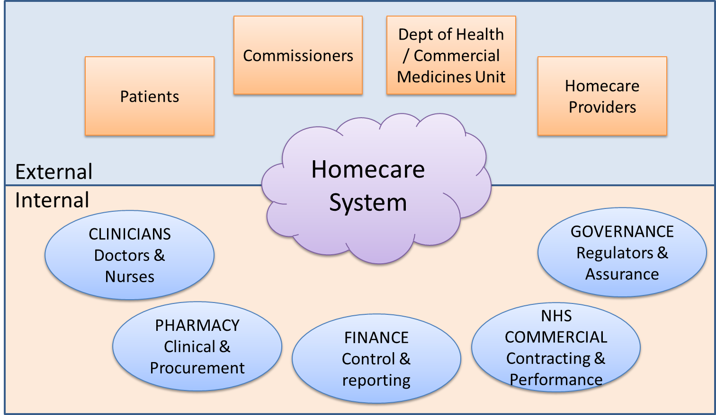

Figure 3 - Stakeholders

## What is an OBS?

An Output Based Specification is commonly used within NHS system procurements to provide a clear description of what is needed. Two definitions are included below:

* “… OBS describes the output requirements for planned investments in new systems and/or services plus any constraints that apply to the proposed solution(s), such as the need to meet national or local standards and the need to interface with existing systems.” (NHS Purchasing and Supply Agency [PASA])
* “… an output- based specification that focuses on what you want, not how to provide it” (Office of Government Commerce [OGC])

So, an OBS is a business requirements document that “wraps” the required functionality of a system (or systems) but does not define how the functionality is to be achieved.

## Systems Development

Homecare improvements are likely to need integration of many different systems for each trust to meet these business requirements in this OBS. The range of integration and scope of development needed will be dependent on the current Trust/Homecare Services working practises and adoption of the Expertise, Toolkit and Standards Workstream (see reference 2).

The following section shows one possible development / adaption of an existing IT service called EPS.

## Electronic Prescriptions Service (EPS)

One such system that might be integrated to enhance Homecare is Electronic Prescriptions Service (EPS) in England, which could also support the transmission of both FP10 prescriptions and “private” NHS prescriptions for Homecare and out-patients. The diagram below illustrates how such a system could be developed to support changes in hospital pharmacy service provision.



Figure 4 - Vision for using EPS in Secondary care

The process flow for Figure 4 is as follows (additional new processes that could also be introduced to support Homecare dispensing have been highlight with yellow):

* This process assumes the following is known:
  + - Patient's NHS number
    - prescribed medication
    - Variable Homecare service charges relevant to individual drugs/prescriptions
* The Homecare dispenser is chosen as follows:
  + - If the patient has a nominated dispenser then that dispenser is used
    - If this prescription needs a specific dispenser then that dispenser is used
    - Otherwise the no dispenser selected.
* Prescription message is created and electronically approved by the prescriber
* Once approved:
  + - The nominated dispenser can download their prescriptions
    - A non-nominated prescription can be downloaded using the Prescription ID. The Prescription ID is normally conveyed to the dispenser on a printed prescription token as text and a barcode. [However, the Prescription ID could be conveyed to a specific dispenser via email or another communications mechanism.]
* The medication is dispensed and issued to the Patient, which:
  + - sends a Dispense (OR a dispatch) Notification message to EPS
    - cross charges the associated hospital directorate.
* Dispensing endorsements related to BSA prescription reimbursement are forwarded to the BSA for processing
* Each month the FP34 paper claim forms are passed to BSA, so BSA can record the number of paper and electronic prescriptions submitted for reimbursement in that month.

# Business Requirements Overview

This section shows:

* the overview of the Homecare key Functional Areas
* and then the individual Homecare Key Processes layered next to each other so they can be compared.

Please note, the same Functional Areas have been located in the same place in all diagrams to facilitate clarity.

## Key Functional Areas

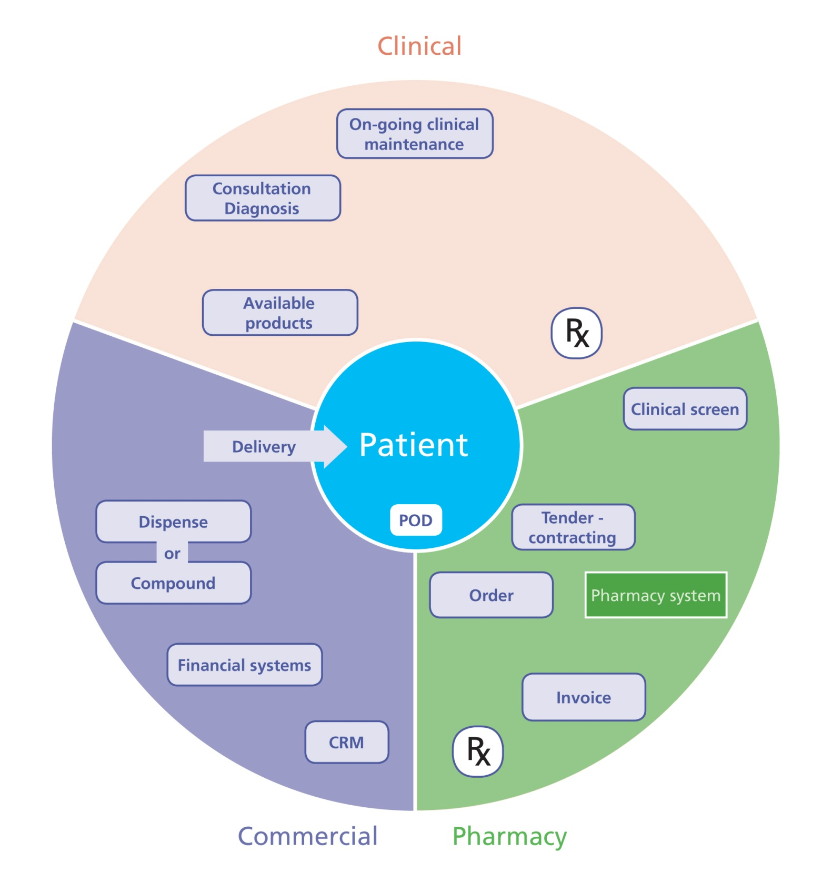

Figure 5 - Key Functional Areas

## Key Processes

The following shows the individual Homecare Key Processes layered on-top of each other to help visualise the similarities and differences:

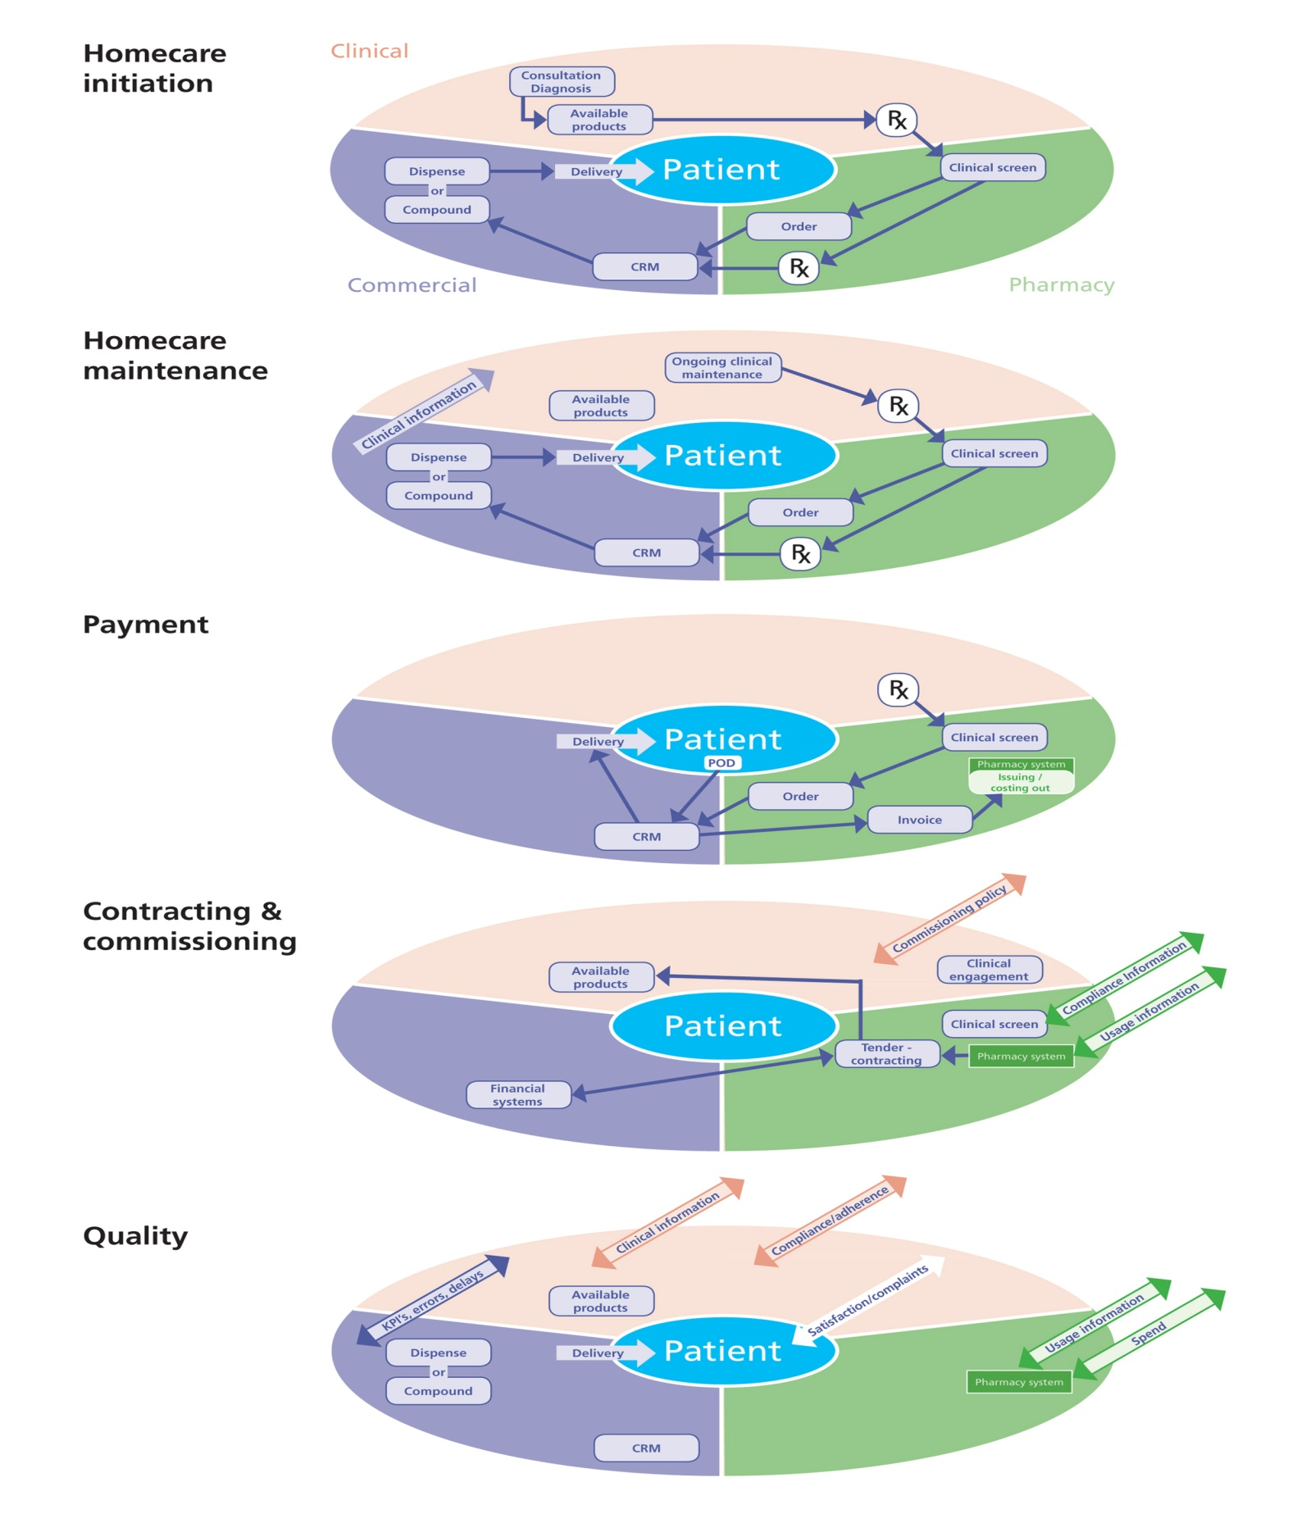

Figure 6 - Key Business Processes

# Prioritised Requirements List

## Fundamentals

Throughout any developing systems involved in the provision of NHS pharmacy services it is a requirement that all relevant applicable data standards are incorporated to ensure interoperability and comply with NHS requirements.

The following examples are SOME of the essential components that will be used across this output based specification as standard. This list is not exhaustive.

* The NHS number – as required by the NPSA safer practice notice (Risk to patient safety of not using the NHS Number as the national identifier for all patients) & the NHS Operating Framework 12/13
* NHS Organisation Data Service code (also known as NACS) – e.g. RLQ
* dm+d – all prescribing and medication related transfers of information to utilise dm+d coding
* HL7 the international framework (and related standards) for the exchange, integration, sharing, and retrieval of electronic health information.
* ICD10 - the International Statistical Classification of Diseases and Related Health Problems (ICD), a medical classification list developed and maintained by the World Health Organization (WHO).
* Royal College of Physicians standards for health and social care electronic records (as defined in Appendix 1).
* Compliance with the EU Falsified Medicines Directive including options for capturing batch number and expiry dates PLUS the ability to capture and record any form of serialisation numbering.
* NHS eClass – the bespoke classification system for products and services. NHS-eClass facilitates the accurate analysis of expenditure and is now administered by NHS Shared Business Services.
* Systems utilising Electronic Transfer of Prescriptions must comply with the Prescribing Systems Compliance Specification (NPFIT-ETP-EDB-0025.20).
* All systems must utilise 128 bit encryption (or greater) for all transactions crossing public networks.

Any system must provide a flexible and comprehensive reporting tool to allow appropriately authorised and audited data extraction. Whilst proprietary systems may be used to link into the homecare system all functionality must be based around open standards for IT systems to allow future developments.

## Prioritisation

Within the following tables the following principles have been used to prioritise the requirements:

1. **Fundamental** – required immediately as part of any system
2. **Priority 1** - required within 12 months of any system being implemented
3. **Priority 2** – required within 2 years of any system being implemented
4. **Strategic** – Provides overall direction of strategic development. Should be used by developers as a route map for intended system development

## Searchable List

The attached Excel spreadsheet holds the following list in a more searchable format.

Furthermore, within the spreadsheet there are 3 pre-sorted worksheets already set-up, sorted by:

* Stakeholder (as listed in the tables below)
* Priority
* Experience (i.e. which follows the business processes defined in Business Requirements Overview chapter)



## Patient Requirements

| **Requirement** | **Output** | **Priority** |
| --- | --- | --- |
| Provision of a single point of contact | Provide simple feedback methods into systems. | Fundamental |
| Deliver digital and traditional systems available in parallel. | Fundamental |
| Allow for mobile device alerts or call centre data entry. | Priority 2 |
| Provide automated responses – e.g. computerised call up to confirm medication delivery. | Priority 1 |
| Provide a patient satisfaction survey process. | Priority 1 |
| Allow patient initiated complaints and issue recording & resolution. | Priority 1 |
| Develop other patient driven support systems e.g. Blog’s, Discussion forums, newsletters. | Strategic |
| Data Management and access to information. | Ensure plain English/ readability | Fundamental |
| Provide a repository for organisational and medication/disease specific Patient Charter documents with overall vision | Priority 1 |
| Provide systems for authorising (and de-authorising) Proxy access to support care management (carers/parents etc) | Priority 2 |
| Provide assurance of confidentiality and, where appropriate, anonymity | Fundamental |
| Provide secure access including support for lost passwords etc | Fundamental |
| Contact/Communication systems. | Manage who (Patient, parent, carer) and how (phone, email, text etc) are patients contacted | Fundamental |
| Information for the patient as to which company and which treatment must be clear in all communication | Fundamental |
| Information as to which hospital is managing the homecare that any contact relates to (as many patients may be accessing clinical services from different providers) | Fundamental |
| Provide English and access other languages for information as a minimum | Priority 1 |
| Provide options for alert systems- fridge temperatures; smart infusion pumps | Strategic |
| Allow for a review progress – provision of a patient perspective, optional diary or log of care and progress. Including an escalation process to the clinical team | Priority 2 |
| Managing Own Delivery | Explain options and allow choice of supplier – which, within a contract process, would include “in hospital” care plus the contracted homecare provider. | Priority 1 |
| Provide flexibility of timing of delivery | Priority 1 |
| Provide visibility of delivery schedule and real-time tracking | Priority 1 |
| Allow patient /carer to make changes | Priority 1 |
| Allow for personalisation – preferences as to contact methods, times of day for contact etc | Fundamental |
| Ensure options for consolidation of supply – not multiple deliveries | Strategic |
| There should be flexibility in delivery system potentially including post, courier, collection from local pharmacy, collection from hospital (as relevant to medication being supplied). | Fundamental |
| Support proxy involvement in changes | Priority 1 |
| Ensure security of supply including escalation process for supply problems | Fundamental |
| Access to a single clinical record – “My Homecare” | Allow patient and authorised carer access to THEIR homecare record | Priority 1 |
| Provide the option to review clinical information | Fundamental |
| Allow for patient/carer entry of clinical problems – side effects | Priority 2 |
| Allow patient to confirm they have been offered choice of treatment (where available) | Priority 1 |
| Information governance | Provide the functionality to see individuals (authorised proxy access) and organisations(NHS Trust and homecare provider) who can access individual patients records | Priority 2 |
| Access to counselling and Medicines Information / patient charter relating to current treatment | Provide access to electronic copies plus the option to request printed copies via telephone help line | Priority 1 |
| Compliance / adherence diary facility | Provide functionality to allow patient to able to enter medication taken, adverse effects and clinical problems encountered. | Priority 1 |
| Support via opt-in for call centre to contact the patient to collect same information | Priority 1 |
| Efficient and transparent process | Pharmacy processes should not adversely impact on the patient’s pathway. | Fundamental |
| Pharmacy actions must feed into the “My Homecare” record to keep patient/carer informed. | Priority 1 |
| Patient satisfaction – including complaints, complements and queries | Provide assurance that complaints, complements and queries are reported and responded to. | Priority 1 |
| Provide access to the overall governance reporting for their homecare provider | Priority 1 |
| Self-funding process for private patients (e.g. IVF) | Provision of invoicing and payment system | Priority 2 |

## Clinical Requirements

| **Requirement** | **Output** | **Priority** |
| --- | --- | --- |
| Exception reporting | Providing information from the homecare provider e.g. Delivery failures, patient issues related to delivery driver etc | Priority 1 |
| Clinical Governance/ Clinical Responsibility | Provide compliance and feedback regarding potential Non-compliance | Priority 2 |
| Review treatment/progress from patient diary | Strategic |
| Patient diary escalated information | Priority 2 |
| Status of prescription – is there a current prescription? Date next delivery due | Priority 1 |
| Access to a single clinical record | Provide access to Real-time clinical data including all entries relating to that patients care from all clinicians and the patient. | Priority 1 |
| Allow for auditable event reporting including admissions, discharges (including link to relevant clinical information e.g. SCR), death etc | Priority 1 |
| Providing reporting on patient entered information including adherence & adverse drug events (ADE’s) | Strategic |
| Display all related Pathology & other recorded clinical data | Priority 1 |
| Display information from homecare company clinical evaluation records during homecare | Priority 1 |
| Homecare formulary and process | Identify available Medication selection (treatment group specific) | Fundamental |
| Identify Supply route options including detailed information on any specific requirements | Fundamental |
| Provide access to Patient charter information for each option | Priority 1 |
| Provide information on any required Funding approval processes including approval status | Fundamental |
| Electronic Prescribing | Functionality to allow for Treatment initiation | Fundamental |
| Provide systems for Clinical scheduling including visits to hospital, clinical nurse specialists, homecare nurses | Priority 1 |
| Provide functionality for prescription management (repeat requests from homecare company) | Fundamental |
| Provide a Stop facility for patients previously on homecare including information on anticipated patient held stocks. | Priority 1 |
| Identification of clinical responsibility | System for clearly identifying which clinician is responsible for which aspect of a patients care (e.g. prescribing, blood testing, results review etc) | Priority 2 |
| Provide a Transfer of care/responsibility audit record for any changes in patients clinicians | Priority 1 |
| Provide system to fully transfer care between organisations – e.g. to a different hospital if the patient moves provider or to a GP. | Priority 1 |
| Formulary and approval process kept up to date | Clinicians engaged in formulary approval process including NICE drugs | Fundamental |
| Formulary links managed via pharmacy computer system | Fundamental |
| Individual patient charters and service provisions linked to the formulary and available to print, email or read online | Priority 1 |
| Electronic Prescribing system | Prescribing system in use supports homecare prescribing including information on products and services provided | Priority 2 |
| Able to prescribe drugs and ancillary items | Priority 2 |
| Prescriptions transmitted to pharmacy for clinical screening and approval/processing | Priority 1 |
| Electronic Prescriptions Services incorporated for NHS and “private” prescriptions | Strategic |
| Paper based backup system available | Fundamental |
| Patient safety | Supports historic NPSA and developing medication safety guidance | Fundamental |
| Clinical Key Performance Indicators – to show service value | Patient satisfaction | Priority 1 |
| Adherence with prescribed treatment | Priority 2 |
| Performance across specialty (granularity of reporting) | Strategic |
| Clinical visits being undertaken and reported (clinical evaluation forms completed) | Priority 1 |

## Pharmacy Requirements

| **Requirement** | **Output** | **Priority** |
| --- | --- | --- |
| Provision of alerts to patient | Allow for opt-in alerts e.g. Check your pump, check fridge temperature etc provided by text, phone-call email etc | Strategic |
| Clinical Governance | Provide patient satisfaction information | Priority 1 |
| Provide patient compliance feedback | Priority 1 |
| Allow for Issue identification, recording and resolution | Priority 1 |
| Provide option for patient and/or healthcare professional Yellow card alerting in relation to their homecare medication | Strategic |
| Access to a single clinical record | Provide access to Real-time clinical data including all entries relating to that patients care from all clinicians and the patient. | Priority 1 |
| Allow for auditable event reporting including admissions, discharges, death etc | Priority 1 |
| Providing reporting on patient entered information including adherence & adverse drug events | Strategic |
| Display all related Pathology & other recorded clinical data | Priority 1 |
| Display information from homecare company clinical evaluation records during homecare | Priority 1 |
| Electronic prescribing – review and authorisation | Provide clinical screening functionality to allow review of prescribed medication to ensure compliance with formulary and clinical governance controls. This must allow for clinical changes to be reviewed, pharmacy specific annotation to be added. | Fundamental |
| Provide information on any required Funding approval processes including approval status. | Priority 1 |
| Record authorisation of prescription by clinical pharmacist. | Fundamental |
| Allow allocation of relevant treatment to categories – NICE, PbR excluded, exceptional funding. | Fundamental |
| Allow transmission on to pharmacy ordering system | Fundamental |
| Homecare formulary | Allow pharmacy to maintain formulary for homecare medication (linked to wider hospital formulary). | Fundamental |
| Allow maintenance of Patient Charter information, supplier information & any required additional registration paperwork | Priority 1 |
| Adherence / compliance information | Allow the clinical pharmacist to review any medicines compliance/adherence information. | Priority 1 |
| Ecommerce processes | Link from ePrescribing review & authorisation | Priority 1 |
| Parallel process to create & transmit electronic purchase order (next to EPS) | Fundamental |
| POD reconciliation | Fundamental |
| Goods receipt | Fundamental |
| eInvoicing | Fundamental |
| eCredit (e.g. for Patient Access Schemes, credit notes) | Priority 1 |
| Clinical Costing & coding | Automate patient level issue “booking out” of Homecare with correct/current costing from eCommerce transaction. | Fundamental |
| Standardised ancillary items including Nursing input, patient training, postage | Priority 2 |
| Interoperability & standardisation /feed into pharmacy systems | Utilise open standards for data communication ecommerce. | Fundamental |
| Key performance indicators | Patient satisfaction. | Priority 1 |
| Operational KPI’s – No. patients (registered, newly registered, “off treatment”, on hold), Deliveries made, Items supplied, Invoicing (value, errors totals) | Fundamental |
| Medication errors (incorrect drug, dose, label, formulation, quantity, expiry) | Fundamental |
| Service failures (Missed/late deliveries, wrong location, inaccurate items) | Priority 1 |
| Automation of KPI reporting | Priority 1 |
| Framework governance reports | Monthly, Quarterly and annual reporting facilities by homecare provider to include financial, performance (KPI), quality and patient focussed information | Priority 1 |
| Report to inform NHS organisation Medical and Nursing Directors of Homecare performance – Template with facility to add narrative and additional details. | Priority 1 |
| Service review meeting template reports | Priority 1 |
| Contract monitoring | ***TBC – Provide a contract monitoring report by homecare provider |  |

## Commercial Requirements

Commercial requirements can further be categorised into the following:

* Homecare Provider
* Commissioner
* Finance
* Other

| **Requirement** | **Output** | **Priority** |
| --- | --- | --- |
| **Homecare Provider Requirements:** | | |
| Communication systems | Allow for Voice, written, electronic (text, email) | Fundamental |
|  | Provide clear communication audit trail – visible to patient and link into CRM system. | Fundamental |
|  | Allow for patient specified schedule of times for communication | Priority 1 |
| Prescription management system | Provide information to support homecare company CRM systems in managing on-going prescribing of homecare | Fundamental |
|  | Allow acute provider review of requested, outstanding and sent homecare prescriptions | Priority 1 |
|  | Provide system of escalation to ensure patient supply is maintained | Priority 1 |
| Access to a single clinical record | For registered and consented patients with that homecare company only:  - Diagnosis, treatment pathways in use  - Clinical outcomes  - Adverse drug events | Priority 2 |
|  | Provide access to Real-time clinical data including all entries relating to that patients care from all clinicians and the patient. | Fundamental |
|  | Allow for review of event reporting including admissions, discharges, death etc PLUS event entry for homecare relevant activity – e.g. home care delivery, nurse administration. | Priority 1 |
|  | Providing reporting on patient entered information including adherence & adverse drug events | Priority 1 |
|  | Display all related Pathology & other recorded clinical data | Priority 1 |
|  | Display information from homecare company clinical evaluation records during homecare | Priority 1 |
| Entry of clinical data | Allow for entry of clinical information relating to homecare services provided. | Fundamental |
| Information on adherence | Allow for entry of any homecare provider gathered information on patient adherence | Priority 1 |
| Patients able to be transferred between care settings | Provide functionality to allow for patients to be transferred between:  - Care settings  - Homecare provider   - Commissioner | Priority 1 |
| Electronic prescribing – review and authorisation | Provide reporting of clinical screening & other key events of the review of prescribed medicines. This must allow for clinical changes to be reviewed, pharmacy specific annotation to be added. | Priority 1 |
| Prescription management system | Link to Homecare company Customer Relationship Management software | Priority 2 |
|  | Access to Electronic Transfer of Prescriptions service (EPS) | Strategic |
|  | Link to hospital pharmacy homecare management team to support local resolution of prescribing issues | Priority 1 |
| Patient switch management | Facility to move patients between homecare providers as contract changes occur | Priority 2 |
| **Commissioner Requirements:** | | |
| Details on clinical usage | Reports (anonymised but commissioner relevant) on diagnosis, clinical role of primary care | Priority 2 |
|  | Reports on delivered services and if commissioned/approved for treatment | Priority 2 |
| Clinical Governance & assurance | Anonymised reports as to if that commissioners patients are using the prescribed treatments | Priority 2 |
|  | Summary Patient satisfaction reports – with indication of the impact the treatment is having | Priority 2 |
| Clinical outcome information | Provide summary anonymised reporting on commissioned service/patient related: | Priority 2 |
| Formulary adherence | Ability to report on approved medication being used for approved indication PLUS un-authorised usage | Priority 2 |
|  | Reporting on patients being offered choice of treatment | Priority 2 |
| Patient satisfaction | Reporting functionality to summarise commissioner’s cohort of patients satisfaction with homecare by company and treatment area. | Strategic |
| Management and minimisation of waste | Provide reporting on drugs not used/wasted by patients but charged to commissioners including error and patient events (clinical changes/death etc)s | Fundamental |
|  | Management of additional costs – extreme delivery choices** | Priority 1 |
| Reporting | Monthly (and consolidated longer period) patient level reporting. By commissioner, drug, indication | Priority 1 |
|  | Patient Access Scheme usage reporting | Priority 1 |
| Approval mechanisms | Identification of commissioning policy – link to patient pathway & drug treatment (local vs. specialised commissioning) | Priority 1 |
|  | Facility for Cohort based, Criteria based access and prior approval (electronic systems) | Priority 2 |
|  | Audit tools to provide assurance of compliance | Priority 1 |
| **Finance Requirements:** | | |
| Wastage | Summary anonymised reports on any medication wastage including stock going out of date, unused deliveries, stock not used when patients die | Priority 2 |
| Current clinical commitment | Summary of on-going homecare by commissioner and clinical condition with medication type – NICE, PbR excluded, Exceptionally funded | Strategic |
| Forecasting – to support clinical contracting | Summary of clinical indication usage over time to support horizon scanning and forecasting. | Priority 2 |
| See Commercial section | See Commercial section |  |
| Reporting tools | Provide (on a monthly basis) the aggregated cost of Homecare services by clinical service in the Trust. This cost being made up of invoices paid and an accrual for goods received but not yet paid for (The accrual being automatically generated by the system). | Priority 1 |
|  | Payment transactional data by supplier e.g. comparison between actual invoice payment date and date included in standard terms, relationship between the value of accruals and invoices paid in the month. | Priority 1 |
| Patient Level Costing | The cost of Homecare for each individual patient so that the relevant commissioner can be charged and so that costs can be directly allocated within the Patient Level Information & Costing system (PLICs). | Priority 1 |
| Patient satisfaction – Value for Money | Develop reporting that reviews the value of spend by supplier with patient satisfaction/quality measures such as late delivery, complaints, incidents etc and also providing intelligence about whether the potential causal factors relate to geography, time of day, type of therapy, whether it's patient or carer feedback. | Priority 1 |
| Appropriate financial controls | Contracting | Fundamental |
|  | Delegation of authority | Fundamental |
|  | Separation of duties | Fundamental |
| Data transfer | Interface between homecare system and finance | Fundamental |
| **Other Requirements:** | | |
| Pharma-company - Information | Provide Pharmacovigilance reporting including yellow card submission | Strategic |
|  | Provide anonymised summary Patient satisfaction reporting on medication specific service relating to Pharma company | Strategic |
| MHRA – Pharmacovigilance | Reporting Adverse Drug Events (Yellow Card information) | Strategic |
| DH reporting | Tools to provide England wide reporting on homecare drug usage | Strategic |
|  | Homecare savings QIPP report | Priority 2 |
| Devolved administrations | Transferability between home countries – allow for cross boarder activity | Strategic |

# Appendix 1 – RCP Health and Social Care Standards for Electronic Records

Currently there is no overarching body responsible for health and social care standards held electronically and passed between IT systems. The Joint Working Group with the Royal College of Physicians (RCP) was set up at the request of the Department of Health to examine the development of Electronic Health Records and recommend how professional requirements and leadership could best support the development of Electronic Health Records (EHRs) in line with national policy.

The following tables shows the agreed standard terminology the Department of Health will be using moving forwards for all medical and health matters (not just Homecare).

| **Preferred Headings** | **Preferred Description** | **Technical Notes** |
| --- | --- | --- |
| **MEDICATIONS & MEDICAL DEVICES** |  |  |
| Medication Name | Generic name (with brand name - as appropriate). | Medication name is an attribute of a medication record.  Use NHS Dictionary of Medicines and Devices (DM+D) |
| Medication Form | For example caplet, drops, tablet, lotion etc | Medication form is an attribute of a medication record.  Form is more commonly used in primary than secondary care, but may be used in secondary care.  Use NHS Dictionary of Medicines and Devices (DM+D). |
| Dose | Unit of measurement, e.g. number of tablets (2 tabs) medications content (e.g. 20mg) | Medication dose is an attribute of medication record.  This is a record of the dose at each administration. It is a combination of ingredient strength and ingredient quantity. Where combination medication eg co-amoxyclav, it may be number of tablets where a single drug, eg. Furosemide, it may be the exact quantity e.g. 20mg.  Use NHS Dictionary of Medicines and Devices (DM+D)  Allow for mass per unit volume format, to allow for liquid preparations.  Consider CUI display formatting |
| Route | Medication Administration Description (oral, IM, IV, etc): May include method of administration (e.g. by infusion, via nebuliser, via NG tube) and/or site of use (e.g. ‘to wound’, to left eye, etc). | Medication route is an attribute of medication record.  Use SNOMED Routes termset |
| Medication Frequency | Frequency of taking or administration of the therapeutic agent or medication. | Medication frequency is an attribute of medication record.  It is used in dose based prescribing where frequency is identified separately.  Plain text or CFH dose syntax |
| Special Requirements | Allows for: * Requirements for adherence support, for example compliance aids, prompts and packaging requirements * Additional information about specific medicines, for example, brand name or special products where bioavailability or formulation issues | ‘Special requirements’ is an attribute of medication record.  It was known as 'additional instructions' in CFH dose syntax model.  Plain text or CFH dose syntax |
| Do not discontinue warning | To be used on a case by case basis if it is vital not to dis-continue a medicine in a specific patient scenario | Do not discontinue warning is an attribute of medication record.  Plain text |
| Reason for medication | Reason for medication being prescribed, where known | Reason for medication is an attribute of medication record.  Plain text |
| Medication status | Status of the medication, i.e. started, stopped, discontinued, suspended, re-instated, reviewed.  Record date for each change in status | Medication status is an attribute of medication record.  Plain text |
| Medication change | Where a change is made to the medication status or to the dose, form, frequency or route, the information is displayed as medication change. | Medication change is an attribute of medication record.  Plain text or drop down of type of change |
| Reason for medication change | Reason for change in medication, e.g. sub-therapeutic dose, patient intolerant | Reason for medication change is an attribute of medication record related to medication status.  Plain text |
| Medicine administered | Record of administration to the patient, including self-administration. | Part of the drug administration record.  Date administered and by whom. |
| Reason for non-administration | Reason why drug not administered (e.g. patient refused, patient unavailable, drug not available). | Part of the drug administration record.  Plain text |
| Relevant Previous Medications | Record of relevant previous medications | Use NHS Dictionary of Medicines and Devices (DM+D), where possible, but may be plain text, e.g. where patient is providing the information.  Relevant previous medications to be communicated between healthcare settings in addition to current medications |
| Medication Recommendations | Suggestions about duration and or review, ongoing monitoring requirements, advice on starting, discontinuing or changing medication. | Plain text  Medication recommendations to be communicated between healthcare settings where relevant. |
| Medical devices | The record of dietary supplements, dressings and equipment that the patient is currently taking or using.  Data items:  *Device name  * Device Identifier  *Batch number  *Serial number | The data items are attributes of medical device record.  Also record start and stop dates, where relevant.  Use NHS Dictionary of Medicines and Devices (DM+D) only for prescribable devices.  Increasing numbers of medical devices contain active pharmacological ingredients. Medical devices should not therefore be separated from medicines in the viewable record. |

# Appendix 2 – Ideal Patient Journey

Figure 2 gives an overview of the patient journey through Homecare prescription / dispensing from a Patient prospective which identified the requirements in the requirements section. Below is a vision of an ideal patients journey in more detail. An online version is available at <http://prezi.com/nbwxm-veksbx/?utm_campaign=share&utm_medium=copy> that will show more image details



Figure 7 - Homecare prescription / dispensing from a Patient prospective

# Appendix 3 – References

1. Homecare Medicines – Towards a Vision for the Future, 2011, Hackett, Mark, Department of Health (Gateway reference 16691). A copy of the Hackett report can be found here <http://cmu.dh.gov.uk/files/2011/12/111201-Homecare-Medicines-Towards-a-Vision-for-the-Future2.pdf>
2. Homecare Governance toolkit for the introduction and use of medicines, 2012, from the National Homecare Steering Board Committee. A copy of the Toolkit report can be found here <http://www.keele.ac.uk/media/keeleuniversity/fachealth/fachealthsop/medmanservices/gpdpresentations/120222%20Homecare%20toolkit%20draft%20sh%20rev6-1.pdf>
3. The latest list of NHS Trust Centres can be obtained from: <http://www.connectingforhealth.nhs.uk/systemsandservices/data/ods/datafiles/data-files>
4. The Operating Framework for the NHS in England 2012/13. <http://www.dh.gov.uk/prod_consum_dh/groups/dh_digitalassets/documents/digitalasset/dh_131428.pdf>
5. National Audit Office report for prescribing costs in primary care, can be found here <http://www.nao.org.uk/publications/0607/prescribing_costs_in_primary_c.aspx>
6. DH paper for “Improving the use of medicines for better outcomes and reduced waste”, can be found here <http://www.dh.gov.uk/health/files/2012/12/Improving-the-use-of-medicines-for-better-outcomes-and-reduced-waste-An-action-plan.pdf>
7. College of Physicians report standardisation of the Electronic Health Records, can be found here “”.

# Appendix 4 – Glossary of Terms

| **Name** | **Acronym** | **Description** |
| --- | --- | --- |
| Board of Commissioners | BOC | Route for PCT to gain agreement jointly. |
| Benefits Tracking Tool | BTT | BTT data warehouse and integrated reporting tool. |
| Clinical Commissioning Group | CCG | Clinical commissioning groups are groups of GPs that will, from April 2013, be responsible for designing local health services In England. They will do this by commissioning or buying health and care services including:   * Elective hospital care * Rehabilitation care * Urgent and emergency care * Most community health services * Mental health and learning disability services |
| Care Quality Commission | CQC | Regulate care provided by the NHS, local authorities, private companies and voluntary organisations. They aim to make sure better care is provided for everyone - in hospitals, care homes and people’s own homes. They also seek to protect the interests of people whose rights are restricted under the Mental Health Act. |
| Clinical Commissioning Group | CCG | Community patient care and commissioning organisation. |
| Combined Panel |  | Review panel consisted of Mark Hackett, as Chair, Steering group and Working group. |
| Commercial Medicines Unit | CMU | CMU work to ensure that the NHS in England makes the most effective use of its resources by getting the best possible value for money when purchasing goods and services. CMU enhance and safeguard the health of the public by ensuring that medicines and medical devices work and are acceptably safe. No product is risk-free. Underpinning all our work lie robust and fact-based judgements to ensure that the benefits to patients and the public justify the risks. |
| Commissioning for Quality and Innovation | CQUIN | The Commissioning for Quality and Innovation (CQUIN) payment framework enables commissioners to reward excellence by linking a proportion of providers’ income to the achievement of local quality improvement goals |
| Department of Health | DH | The Department of Health provides strategic leadership for public health, the NHS and social care in England. |
| Drug and Therapeutics Committee | DTC |  |
| Electronic Prescribing Analysis and Cost | e-PACT | A service for pharmaceutical and prescribing advisors, which allows real time on-line analysis of the previous sixty months. The prescribing data, held on NHS Prescription Services’ Prescribing Database |
| Electronic transfer of Prescriptions Service | EPS | Existing system which may be enhanced to support the transmission of both FP10 prescriptions and “private” NHS prescriptions for Homecare and out-patients |
| General Practitioner | GP | A medical practitioner who typically the first medical professional a patient will see and as such treats wide variety of illnesses and provides preventive care and health education for all ages and all sexes |
| Healthcare Resource Groups | HRG’s |  |
| High Cost Drugs | HCD |  |
| Home Parenteral Nutrition | HPN |  |
| Homecare |  | Homecare is defined as a service that regularly delivers medicine supplies and associated care, directly to a patient’s choice of location. Homecare services are split between those which are set up by the Pharmaceutical industry for individual products and those services which are contracted to an NHS specification |
| Hospital at Home |  | Arrangements made to avoid admission to hospital or to facilitate early discharge from hospital by administering medicines, often via the intravenous route, in the patients home – **This type services is NOT included within this Output Based Specification** |
| Interoperability |  | The use of specific, fundamental standards in IT systems to support effective communication between systems. Full 2 way access must allow information to automatically flow between systems within standardised messaging formats |
| Key performance indicators | KPI’S | Key Performance Indicators are quantifiable measurements, agreed to beforehand, that reflect the critical success factors of an organisation. |
| Manufacturer derived scheme |  | Process by where the manufacturers of the product works with a homecare provider to ensure their product/s are delivered to a patient at home. The NHS has no relationship or involvement with this arrangement other than paying for the product and service which is bundled together. |
| Multi-disciplinary team |  | Collaborative efforts of professionals from different disciplines toward a common goal. Can be made up of Consultant’s, Clinician’s, Nurses, Pharmacists and Healthcare Workers. |
| National Clinical Homecare Association | NCHA | Represents and promotes the interests of industries whose business is substantially to provide medical supplies and/or clinical services directly to patients in the community within an appropriate quality framework. Provide a forum for lobbying on issues that affect homecare. Set and debate policy decisions with the National Homecare Medicine Supply Committee and other relevant government bodies. |
| National Health Service | NHS | English Health Service. |
| National Institute for Health and Clinical Excellence | NICE | NICE is an independent organisation responsible for providing national guidance on promoting good health and preventing and treating ill health. |
| National Patient Safety Agency | NPSA | Lead and contribute to improved, safe patient care by informing, supporting and influencing organisations and people working in the health sector.  An Arm’s Length Body of the Department of Health and through three divisions covers the UK health service. |
| National Prescribing Centre | NPC | Supports the NHS, and those working for it, to improve quality, safety and value for money, in the use of medicines for the benefit of patients and the public |
| Output Based Specification | OBS | It can be considered as a “wrapper” to describe the functionality required of a range of different systems supporting the provision of homecare. |
| Payment by Results | PbR |  |
| Pharmaceutical Price Regulation Scheme | PPRS | A British mechanism for determining the prices the NHS pays for brand name drugs. |
| Primary Care Trust | PCT | Community patient care and commissioning organisation (replaced by CCG in April 2013) |
| Quality, Innovation, Productivity and Prevention | QIPP | QIPP is a large scale transformational programme for the NHS, involving all NHS staff, clinicians, patients and the voluntary sector and will improve the quality of care the NHS delivers whilst making up to £20billion of efficiency savings by 2014-15, which will be reinvested in frontline care. |
| Royal College of Physicians | RCP | <http://www.rcplondon.ac.uk/about> |
| Serious Untoward Incidents | SUI’s | An SUI is in general terms something out of the ordinary or unexpected, with the potential to cause serious harm and/or likely to attract public and media interest that occurs on NHS premises or in the provision of an NHS or a commissioned service. |
| Service Level Agreement | SLA | A service level agreement (frequently abbreviated as SLA) is a part of a service contract where the level of service is formally defined. In practice, the term SLA is sometimes used to refer to the contracted delivery time (of the service) or performance. |
| Strategic Health Authority | SHA |  |
| Sub-contractor |  | A subcontractor is an individual or in many cases a business that signs a contract to perform part or all of the obligations of another’s contract. A subcontractor is hired by a general contractor (or prime contractor) to perform a specific takes as part of the overall project. |
| Summary Care Record | SCR | The electronic patient record, centrally held, that contains information about the medication taken, allergies suffered and adverse medication events individual patients |
| Trust/Organisation |  | Strategic health authorities are responsible for the performance of NHS organisations known as trusts. This includes primary care trusts (PCTs), acute trusts, mental health trusts, Ambulance service trusts and foundation trusts. Please see Reference 3 for a full list |
| Value Added Tax | VAT |  |
| Value for Money | VFM |  |

1. <http://cmu.dh.gov.uk/files/2011/12/111201-Homecare-Medicines-Towards-a-Vision-for-the-Future2.pdf>
2. <http://www.uhs.nhs.uk/AboutTheTrust/PlansPoliciesAndStrategies/HomecaremedicinesTowardsavisionforthefutureimplementingtherecommendations.aspx>
3. <http://www.keele.ac.uk/media/keeleuniversity/fachealth/fachealthsop/medmanservices/gpdpresentations/120222%20Homecare%20toolkit%20draft%20sh%20rev6-1.pdf>